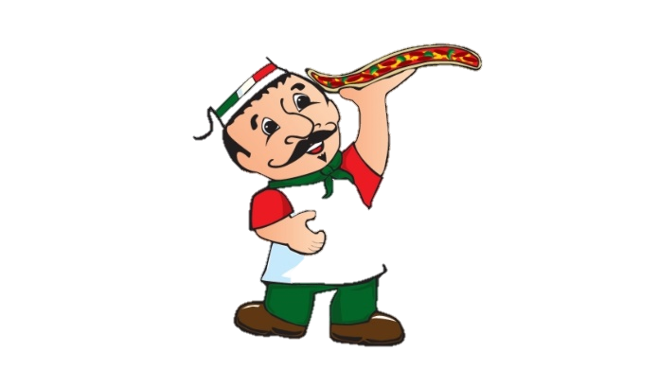
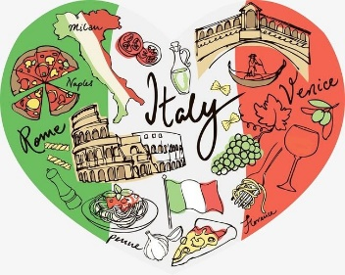
Year 4 Home Learning – Wednesday 3rd June 2020
Please email us your work to:
Year4@highworthcombined.co.uk
Remarkable Writing!

Welcome to

One of the first things many people associate with Italy is pasta and pizza. We would like you to create your very own pizza and write some instructions so that someone else could make it, so it needs to be a ‘real’ pizza!

First think about your choice of toppings (we suggest no more than 5!). For your list of ingredients, you will need to consider the quantities you will need of each ingredient.

When you write your method, you should:
- Use imperative (bossy) verbs and the sentences should mainly be commands. There is a word mat and some ideas of how to use imperative verbs below.
- You could also include some adverbs to say HOW the action should be completed (quickly, carefully etc).

Remember to add an exciting name for your pizza creation!

There is a writing frame attached below if you would like to use it, but please also feel free to present this in your own way.

Challenge:
You could research, and include, how to make the pizza dough too!

You could write a second set of pizza making instructions for an imaginative version, rather like the George’s Marvellous Medicine on the matrix for Friday 15.5.20.
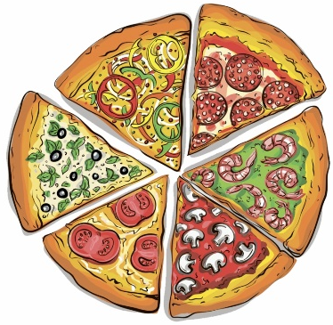

Resilient Readers!

Firstly, please remember to keep reading for at least 20 minutes a day!

In line with our Italian theme, the reading challenge we have chosen will help you learn more about Italy.

The text and questions are attached as a separate document with the Year 4 home learning matrices. Attached to the separate document there is also an Italian themed word search for you to enjoy!

Super Science!  Today we will begin with a question.  What do you think would happen if you were to  drop 2 objects of the same size, but with  different weights, from the same height?  Let’s investigate!  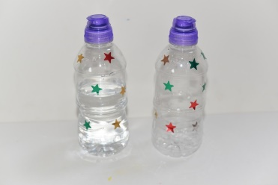  - half fill one plastic bottle with water  - leave another (the same size) empty  - drop them from the same height  - Observe to see which one hits the ground first  Answer the following questions.  - What did you observe?  - What makes this a fair test?  - Do you have any questions after carrying out the investigation?  - Why do you think that we recommend you repeat the experiment a few times?  STOP- do not read on until you have done the investigation  WHAT IS GRAVITY?  Gravity is a force that pulls objects towards the Earth. It’s the reason we walk on the ground rather than float around. Gravity also holds Earth and the other planets in their orbits around the Sun.  GALILEO AND GRAVITY  Galileo was a famous Italian scientist in the 16th and 17th Century. His most famous observation was that two objects of the same size, but different weights hit the ground at the same time if they are dropped from the same height. This happens because the force of gravity acting on both objects is the same.  Think carefully about the observation Galileo made. Do you think that a feather and a hammer, if dropped from the same height, would hit the ground at the same time? Explain your thinking. | Terrific Topic!  Over to you!  There are lots of options for activities related to Italy because it is a country full of history and culture.  Can you do some research and create a fact file or poster for one of the following:  Galileo Galilei (there is some information below to help you).  A different famous Italian (there are plenty to choose from!).  Italy, the country, using the information you have learnt from the reading comprehension.  Choose a famous landmark in Italy to research.  Find out about the true story of Pompeii.  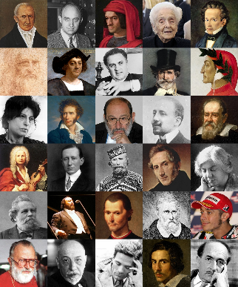  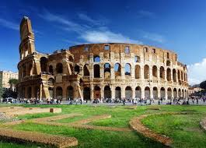  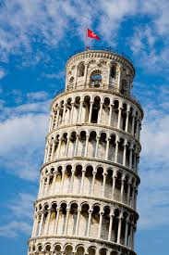
Marvellous Maths!  Roman Numerals today  Look at the first Maths worksheet below to remind yourself how to write Roman Numerals. You could use this link if you have access to the internet: https://www.youtube.com/watch?v=IuioW-43Vtg  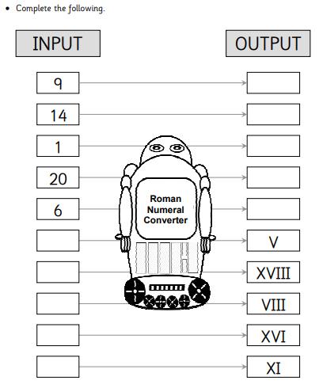  Let’s practice. Write the following in Roman Numerals:-  - The number of doors in your house (don’t forget the cupboard doors!)  - The number of toes on all the people living with you  - The sum of the ages of the people in your family  - Today’s date  Below are some more Roman numeral activities for you to enjoy. | Wonderful Wellbeing!  Today’s winning way to wellbeing is:  Keep Learning  Today you are going to learn to count to ten in Spanish. Click on the links to see clips.  https://www.youtube.com/watch?v=xeHkM9xT1VY  https://www.youtube.com/watch?v=Q6ojH4UU_qk  Now that you can count to ten, can you teach someone else to do the same?  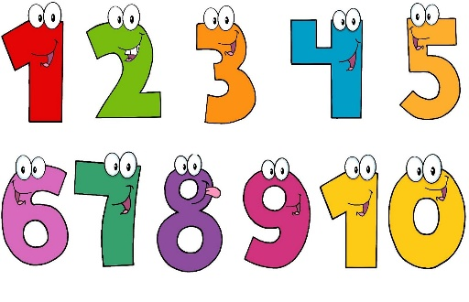

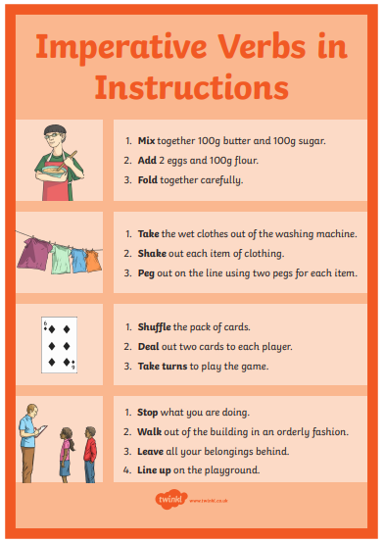
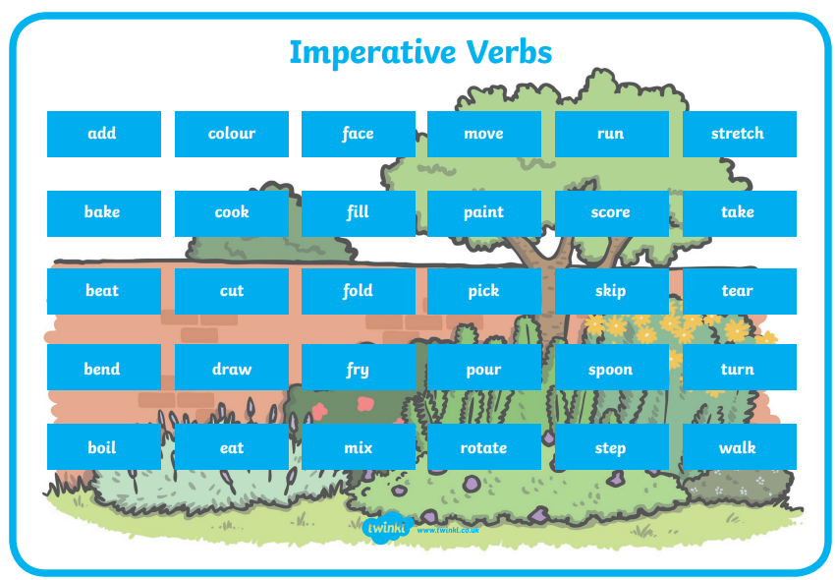
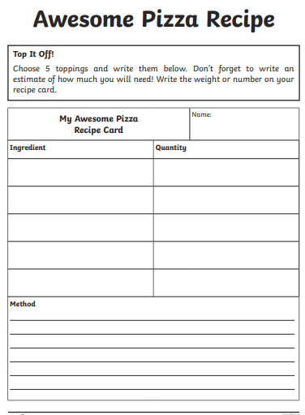
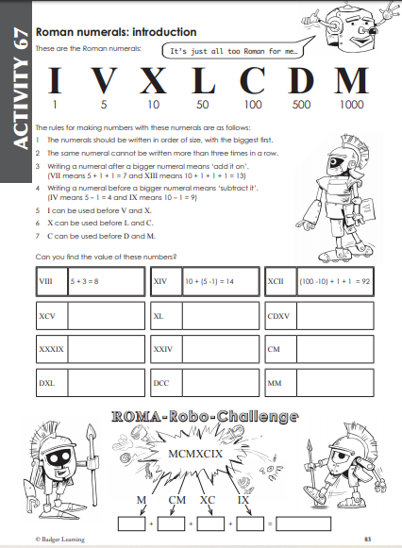

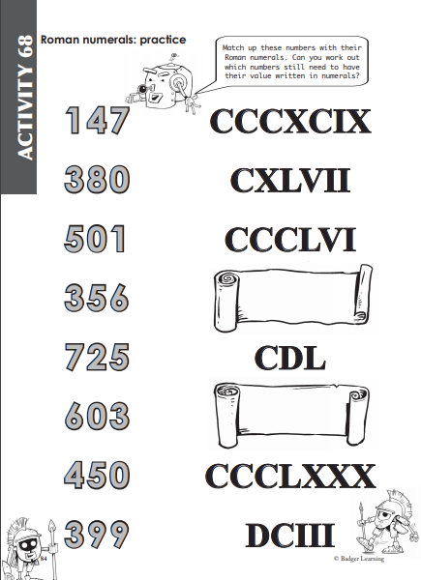

Extension task:
