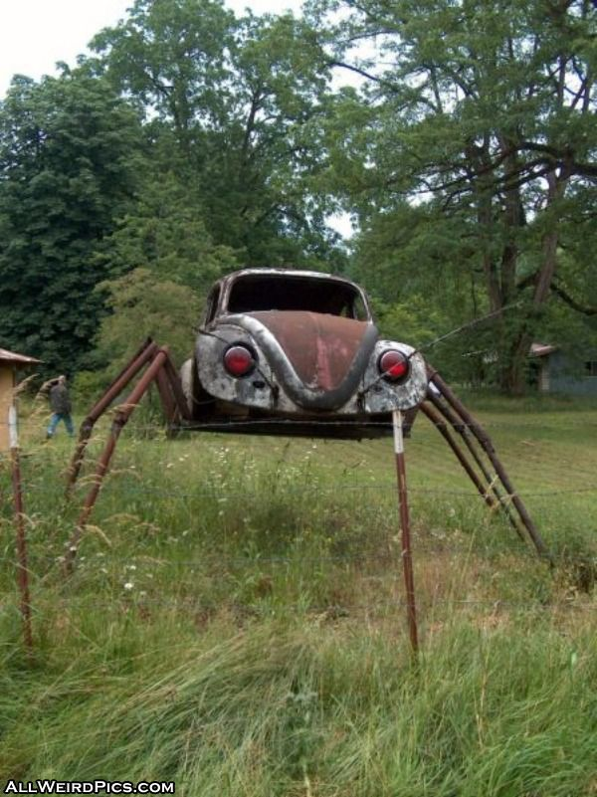
A new type of car has just been invented: The Spider car. Write about all the cool features of this car. Then invent your own cool car.

