Year 2 Home Learning
Week Commencing 29 June 2020- Friday
Please send your work to- year2@highworthcombined.co.uk

English Task  Watch the following video about meerkats.  https://www.literacyshed.com/catchit.html  Sort the sentences into two groups. Past tense and present tense.  Remember- The past is used to describe things that have already happened (e.g., earlier in the day, yesterday, last week, three years ago). The present tense is used to describe things that are happening right now, or things that are continuous.  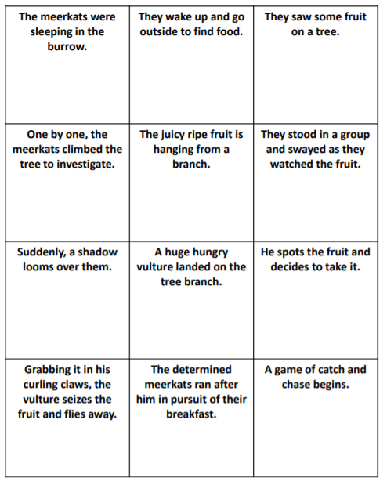 | Maths  Warm up-  - 60 + 43= ___  - 20 - 13 = ___  - 9 x 10= _____  - A quarter of 12 is ___  Measure-  Problem sloving with length.  Today there will be a series of word problems. Look at the examples on the link below and complete the activites attached.  https://www.bbc.co.uk/bitesize/articles/zdfq4xs  Remember to look carefully at the word problems and identify the key information. You will need to work out what operation is needed.  You might find it helpful to draw a bar model or a picture.
Art  Aboriginal art is art made by indigenous Australian people. It includes work made in many different ways including painting on leaves, wood carving, rock carving, sculpting, ceremonial clothing and sand painting.  The backgrounds of these art works were never blank. There is always a continuous use of dotting, patterns, lines or hatching to create a sense of movement within the work.  Have a go making your own piece of aboriginal art.  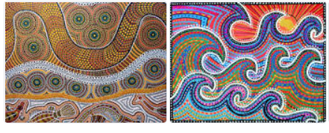  Challenge-  We have looked at a type of art before that used dots. Can you remember what it was called?  If you would like to learn more, have a look at the following website-.  https://art-educ4kids.weebly.com/aboriginal-art-and-patterning.html | Vocabulary  Homophones- These are two or more words that sound the same but have different meanings and some times different spellings.  Look at the word bat- A baseball bat and the nocturnal animal bat are considered a homonym because they are spelled and sound the same but have different meanings.  Here are a few other examples-  -lie. It can mean lie down or to tell something that is unkind.  -bear- the animal or to put up with something  - rose- the flower, the past tense of rise  Write two sentence with each word using it in a different way each time.  Challenge- how many other homophones can you list?
Wellbeing  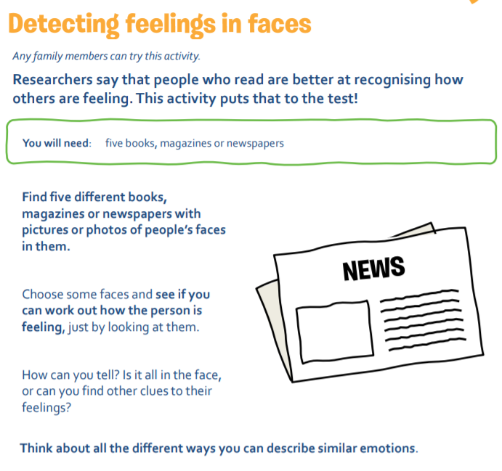 | PE  Throwing and Catching  Basic ball skills  - Bounce the ball and catch it with two hands.  Tip: remember the W shape with your hands.  2. Throw the ball in the air clap and catch the ball.  3. With a partner, throw and catch the ball between you.  Challenge  How many times can you do each of the activities without dropping the ball? Challenge the others in your family.  