Home Learning Ideas for all
Monday 11th May 2020

Woodland Trust
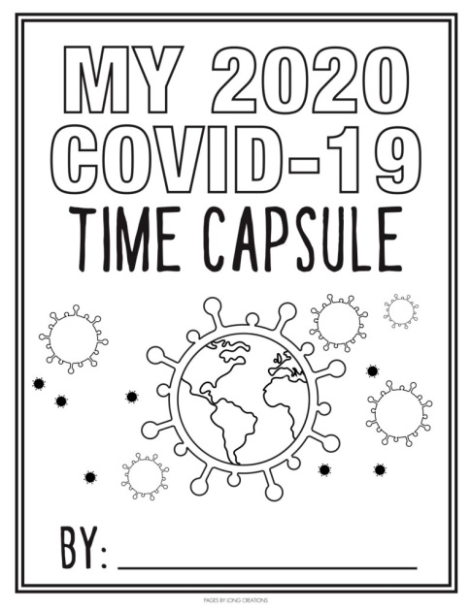
This website has some great resources which you might like to use during your daily exercise. You can find scavenger hunts, tree identification sheets, minibeast quizzes and lots more! http://treetoolsforschools.org.uk/categorymenu/?cat=activities
Time Capsule
In what is a very strange time for us all, we are currently living through a time which children in the future will most likely learn about. With that in mind, we thought this Covid-19 time capsule activity pack may be a useful resource for you to complete at home with your children. If you follow this link, you will find it saved on our school website on the ‘Wellbeing’ page. https://highworth.eschools.co.uk/cms_manage/edit_page/476538

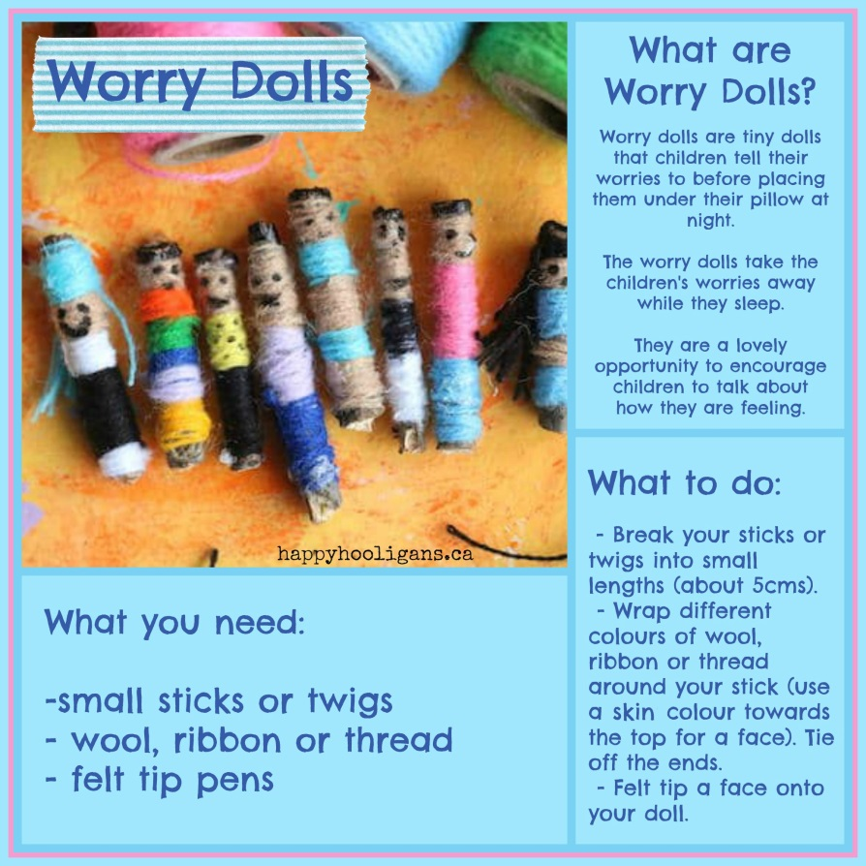
Worry Dolls

