**Extra Home Learning – HID Children No 5 - Monday 11th May**

To replace some of the tasks in the class home learning you may wish to try some of these. Parents, please simplify or extend depending on needs and age of children. Have fun! Lots more signing this time! Go to **Signed Stories** and use the arrows to find the story ‘***Little Rex.’***’ More signing from Mrs Mills and a poem by Ms Pereira on the

website under Hearing Impaired Department. You need to download stories and

power points separately as they take a long time to download.

Don’t forget to email me your child’s learning [hid@highworthcombined.co.uk](mailto:hid@highworthcombined.co.uk)

|  |  |
| --- | --- |
| **Signed Stories**  **‘Little Rex’**  Watch the signed story of ‘***Little Rex’***   1. Draw a picture of Rex and describe what he is like 2. Why did he say he was not scary at the end?   **Year 6**: watch the recording by Mrs Mills on Kensuke’s Kingdom before continuing with English work. The videos are on the website:   1. Yr6 Introduction from Mrs Mills 2. Yr6 KK Recap 3. Yr6 KK Chapter 7 | **A Poem from Ms Pereira**  I have done something completely new and made up a poem! It is called ‘No Time for School Now!’  I have written it and signed it in BSL. Read it, watch it and see if you can illustrate it.  **I need lots of pictures!**  You can write or sign a poem of your own.  The poem is written below and the BSL version is saved separately on the website |
| **Find My Word Game**  Write a word in big letters on a card. Cut up the letters and hide them. Ask someone in your family to find the letters and make up the word.  Then someone in your family can have a go and you can find the letters. See how many you can find. Make a list by sticking the letters together again and send it to me.  Can you write a sentence with your words?  You can use words on the PhoG Chart if you have one at home. | **Trying Something New! Your Turn**  I did something completely new by writing a poem. I don’t normally write poems.  Now it’s your turn.  Draw a picture of something you have done during the closure that you have never done before. Write about it or sign what it was like. |
| **Reading**  Read the story ‘**Riding to Craggy Rock’** on the powerpoint saved separately.  There are signs to go with some of the words and questions to answer. | **Looking and Thinking Activity Stop Them!**  Look carefully at the picture below about ‘Stop Them’ and answer the quiz. There are 2 quizzes, A and B. Start with A and if you can you can do B as well.  See below for the activities |

**See 6 more pages below:**

1. Poem by Ms Pereira
2. Signs and Questions for story ‘Riding to Craggy Rock’
3. Looking and Thinking picture and questions A and B

Closure Poem titled ‘**No Time for School, Now**!’

Staying at home,

My family and me,

Not much to do,

Not much to see.

Can’t play with friends,

Or play with them at school.

Just stay at home.

That’s the big rule!

Can’t play football,

Or watch it on TV.

Can’t play sports,

In pairs or teams

Get so bored,

Every day

Can’t go anywhere,

Worse when it rains.

BUT

Games on the computer,

We can play

Fun to make our own,

To play every day

Go for a walk,

Down the road to the park.

Watch the birds fly,

Dogs running as they bark

Playing in the garden,

Maybe plant some seeds

Cooking is fun,

Yummy things to eat

On the Highworth Website

Lots of things to do

English…., Maths….mmm

Fun things too!

A letter from my teacher,

I can see.

I think she would like,

One from me!

I want to make a rocket,

And make it zoom.

I think mum would rather,

Me tidy my room!

Shall I be an artist?

Maybe a cook?

Perhaps a writer?

I want to write a book!

Ideas in my head,

Different and new.

No time for school, now!

**Far too much to do!!!**

Poem by Ms Pereira

(Inspired by ‘Once Upon a Time’ by John Prater)

**Please create some pictures for my poem and send them back to me.**

**There is a BSL version on the website.**

Signs for words in book ‘Riding to Craggy Rock’

C:\Documents and Settings\apereira\Desktop\Sign & Write Resources\BSL line drawings\BSL_adult\fast.emf

C:\Documents and Settings\apereira\Desktop\Sign & Write Resources\BSL line drawings\BSL_adult\fire.emf

C:\Documents and Settings\apereira\Desktop\Sign & Write Resources\BSL line drawings\BSL_adult\cold.emf

C:\Documents and Settings\apereira\Desktop\Sign & Write Resources\BSL line drawings\BSL_adult\storm.emf

burnt

shiver

Thunderstorm

All of a sudden

C:\Documents and Settings\apereira\Desktop\Sign & Write Resources\BSL line drawings\BSL_adult\favourite.emf

C:\Documents and Settings\apereira\Desktop\Sign & Write Resources\BSL line drawings\BSL_adult\watch.emf

C:\Documents and Settings\apereira\Desktop\Sign & Write Resources\BSL line drawings\BSL_adult\big.emf

C:\Documents and Settings\apereira\Desktop\Sign & Write Resources\BSL line drawings\BSL_adult\fireworks.emf

favourite

Look out

enormous

lightning

flashed

Riding to Craggy Rock

*Answer these questions from the story:*

1. Where did Ben and Mitch go for their holiday?

2. Why did the family ride to Craggy Rock?

3. What things did they take with them to Craggy Rock?

4. What was the weather like when they started their ride?

5. What did they see from the look-out?

6. Why did they run away from the trees?

7. Why did Mum give Mitch some chocolate?

8. Why did they go home early and not go to Craggy Rock?

9. Do you think the family were well prepared for their ride? Why?

**Task:**

**Make a poster showing what things you need to take with you on a trip to Craggy Rock. What would you pack?**

**Looking and Thinking Activity:**

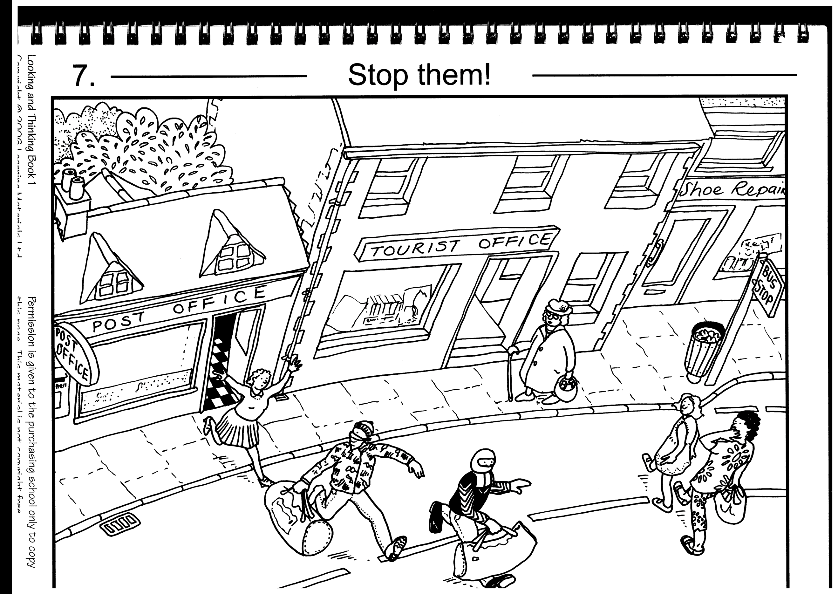

**See below for Questions A then Questions B for ‘Stop Them’**

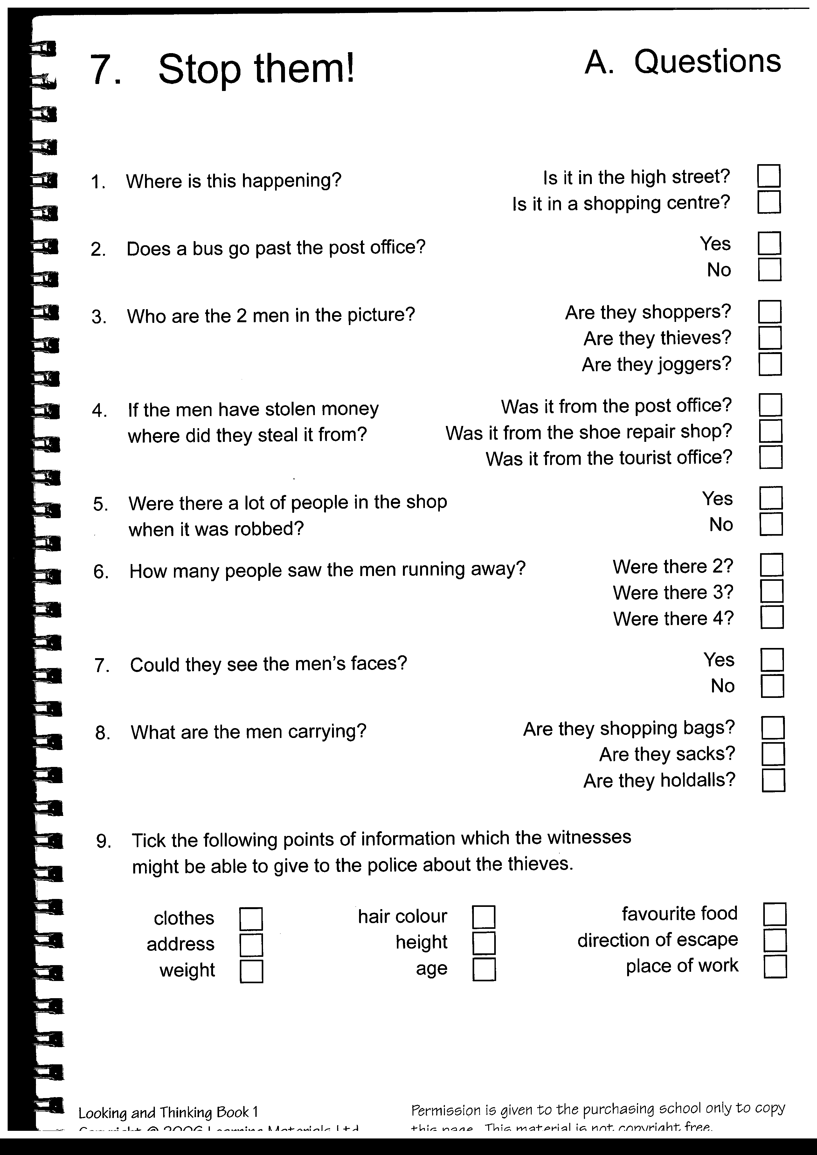

**Now try Questions B**

**Questions B**

**Quiz B for Stop Them**

**Answer these questions in your book or sign the answers:**

1. What time of the day do you think it is?
2. What do you think the people will do next?
3. Why are there no police in the picture?
4. Why are the men’s faces covered?
5. What do you think the men are carrying in their bags?
6. Which way will?
7. What will the men do next?
8. When the police arrive at the post office, what will they do?
9. Who would the old lady not be able to collect her pension at the post office?

**Tasks**:

1. Draw a picture of what will happen next.
2. Draw speech bubbles from the people in the story and write what they are saying.
3. Sign what is happening in the picture and/or write a story about the picture