Year 4 Home Learning – Friday 15th May 2020
Please email us your work to:
Year4@highworthcombined.co.uk
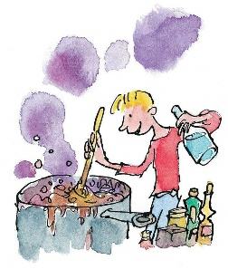  Remarkable Writing!  Fun Friday includes fun writing!  Many of you will have read George’s  Marvellous Medicine by Roald Dahl.  If not, you can listen to an extract that  will help with this writing with this link:  https://www.bbc.co.uk/teach/class-clips-video/english-ks1-ks2-georges-marvellous-medicine-by-roald-dahl/zry7pg8  You are going to create your own version of George’s Marvellous Medicine. The recipe from the story is included below to help you out.  To get ideas, go for a walk around your house and outdoors, if you can. What will you include? Jot down your ideas and any amazing vocabulary that springs to mind.  Your writing must include:  A catchy title.  A list of ingredients and the quantities needed.  Step by step instructions.  Imperative (bossy) verbs to start the sentences (see below).  Your writing should include:  Incredible ingredients using amazing alliteration.  Absolutely awful adverbs (ideas below).  Some sweet persuasion (ideas below).  Your writing could include:  Sassy, silly similes.  A proper noun, horrendous adjective and noun (eg Hilda’s horrible hairspray). In this case, all with alliteration too!  Some lines written as rhyming couplets.  Some onomatopoeia for impact.  Also think about how to present this piece of work to make it eye catching!  Challenge: can you write a friendship (nice, kind) version of this? If you would rather do this, use the same vocabulary challenges but flip them to kind verbs, adjectives etc. | Splendid SPaG!  There is a George’s Marvellous Medicine Wordsearch attached below for you to enjoy.  Can you create your own wordsearch using words from your writing today?  Write a definition for each of the words listed.  Write the definitions as if they were for a dictionary but do not copy the definition from anywhere – you must put it in your own words!  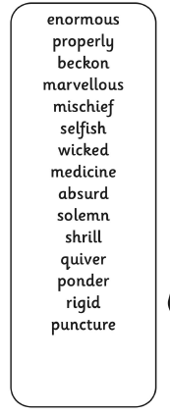  Challenge: Can you put the words in alphabetical order? Can you add some of your own words from your writing?

Wonderful Wellbeing!  Please continue to complete the Ramadan acts of kindness calendar you started.  This week’s winning way to wellbeing is:  Time to spend some quality time helping someone at home. You could help an adult to prepare a meal, help someone to tidy something, help a younger sibling with their home learning … The options are limitless.  Think of something you could do to brighten the day of someone else’s. Do it.  Now consider;  - How, what you did impacted on the other person  - How the other person reacted  - How they showed appreciation  - How you felt afterwards | Terrific Topic!  We would like you to have fun researching a topic of your choice. It could be:  - A time in History  - A Geography related theme  - A famous inventor, artist or explorer  The most important purpose is for you to learn some new knowledge.  You can present what you find in any way you choose. Examples include: a poster / fact file, information text, or you may be able to ask an adult to video you making a short news style report about what you have found out.  Most of all, have fun learning about something of your choice!  We look forward to hearing all about it!
Marvellous Maths!  Times Tables and division practice for quick recall. You can use this link: https://www.topmarks.co.uk/maths-games/daily10 Don’t forget you can use Daily 10 to practice other mental maths skills too! Let us know about any you have tried and how you got on.  Remember that you can practice these skills without the internet, using the ideas in the previous matrices.  X and ÷ by 10 and 100  Let’s refresh our memory. Think carefully what happens when we multiply a number by 10 or 100.  Can you explain it to someone else?  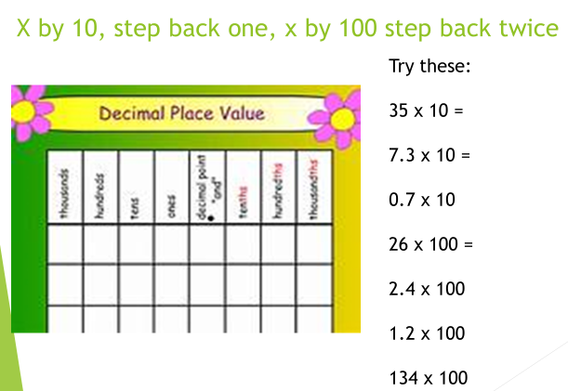  What about if we divide by 10 or 100? | Super Science!  Time for Reach Out Reporter  https://www.reachoutreporter.com/news-update/whales-eye-view-new-volcano-theory-virtual-reality-you-can-feel/  Watch the clip by clicking on the link above and then discuss the following questions with someone at home.  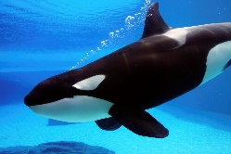  Whale’s-Eye View  - What relationship are the scientists studying?  - How do you think the videos could help the scientists with their research?  - Apart from breathing air, what else do all mammals have in common?
- Here is a list of ingredients to make 12 cupcakes
90g butter
75g sugar
110g of flour
2.5ml baking powder
2 eggs
7.5ml vanilla essence

Susan wants to make 120 cupcakes to sell at a bake sale.
- How much of each ingredient will she need?

- Here is a list of ingredients to make 500 chocolate brownies.

900g chocolates
1800g butter
2200g sugar
1000g of flour
2400g nuts
50ml baking powder
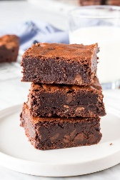

Ezra wants to make 25 brownies for his party.
- Ezra has 70 g 0f butter and 100g of flour and plenty of the rest of the ingredients. Will he have enough butter and flour? Explain.
- How did he work out how much of each ingredient he needed?

