Year 1 Home Learning – Friday 22nd May 2020
https://www.youtube.com/watch?v=PrqwiStOl60&feature=youtu.be this is a link for parents to show how to share the RWI books and oxford owl books.
https://www.youtube.com/channel/UCo7fbLgY2oA_cFCIg9GdxtQ this is the link for the daily phonics lessons.
Below, you will find 6 home learning tasks. You may choose the tasks that you wish to complete and do them in any order. Please do not hesitate to contact us if you have any queries or would like to share the work you have been doing.
year1@highworthcombined.co.uk
After today, it is the start of the half term holidays, so we just wanted to let you know how proud we have been of all of you who have attempted some home learning and continued with your education whilst we have been apart. Please enjoy this half term break and know we will be thinking of all of you. We have tried to make todays activities as fun as possible, so we hope you enjoy them, also feel free to go back and attempt any of the previous home learning tasks that you haven’t tried yet. Keep Safe!
Design Technology  Today we would like you to make and design your own board game and play it with your family.  Firstly, do you have any board games that you like to play at home? Or a game you have played with previously.  Think carefully about what it was that you liked about the game, how did you play and how did you know who had won?  Now decide if you are going to make your own version of a game, you have played before e.g. snakes and ladders. Or are you going to make and design a completely new game.  Design your game, make your game, write the instructions for your game, and then PLAY your game with a family member.  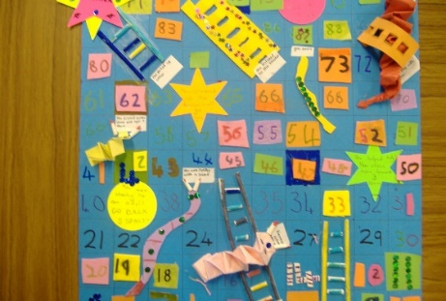 | Wellbeing  I am a wonderful person rainbow.  You are all fantastic great people and we would now like you to think about what makes you so great!  Draw a rainbow like the one below. On each line of your rainbow write something about yourself e.g.  I am good at…  I am most happy when…  I like myself when…  I am proud of me when…  I am special because…  I am a good friend when…  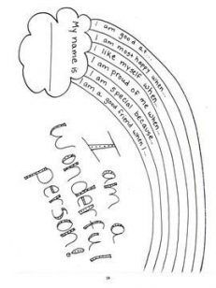  When you have completed your writing, please make it as bright and colourful as you can and display it in your house.
English
Today we would like you to play a game. You will need a pencil, paper and a dice.
Roll the dice and for each number you get complete the activity.
If you roll:
Write a sentence with 2 adjectives in (adjectives are describing words).
Write a question. Do not forget to include a question mark.
Write a few sentences that use speech marks “ ” to show someone is talking in your sentence. Try to use an alternative to said e.g. whispered, shouted.
Write a SILLY sentence. Can you end it with an !
Write the days of the week, months of the year and number names zero- twenty. Don’t forget to check your spellings.
Write your alphabet both in capital and lowercase letters and make sure all your lower case letters are neat and in the pre-cursive style.

Science  This activity needs an adult, as you will be using water.  We would like you to try to make a rainbow.  Light travels in waves as it is made of a mixture of colours. When it travels through water, it changes speed and is bent (refracted). The different colours have different wavelengths and this makes the colours disperse into a spectrum of colours (into a rainbow)  You will need: a glass bowl of water, a sunny place, and a piece of white paper  - Place your bowl of water on a sunny windowsill or in the sun outside.  - Look around the glass bowl, on the floor, walls etc. to see if you can see a rainbow.  - It may be easier to see the rainbow by moving a piece of white paper near the glass.  Did it work? What colours did you see? What happens if you move the water out of the sunshine?  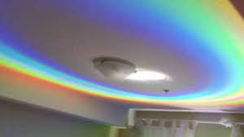 | Maths  - Make some number cards 1-8, gather 20 objects or make a number line  - Turn the cards face down  - Ask a family member to play with you  - Take it in turns to turn over a card  - Look at the table below for the numbers next to the number card  - Then race to say a number sentence using the numbers in the box that is correct.  - The winner then writes the number sentence and checks the answer using objects or a number line.  - The winner is the person who is the quickest with the most correct number sentences.  E.g. I turn over a 2 card, On the table below I have the numbers 9, 3,6 in the number box so I say  “9-3=6” I then write this down.  I could have also said “9-6=3 or 6+3=9 or 3+6=9”. I then check my answer using a number line or objects to help me.  Number card Numbers Number sentence and answer  1 16 7 9  2 9 3 6  3 11 5 6  4 10 9 1  5 14 5 9  6 12 8 4  7 15 7 8  8 20 10 10
Art
Today using the materials that you have at home we would like you to make as many rainbows as possible. Try and be as creative as you can. You could draw and paint your rainbow or make it in another way, perhaps you could make a giant rainbow with toys, food or clothes!
Below are some ideas - we look forward to seeing photos of what you make.

