Home Learning Ideas for all
Thursday 19th March 2020

In addition to the home learning ideas sent home yesterday, below is another free home learning resource with ideas from Nursery up to Year 6…
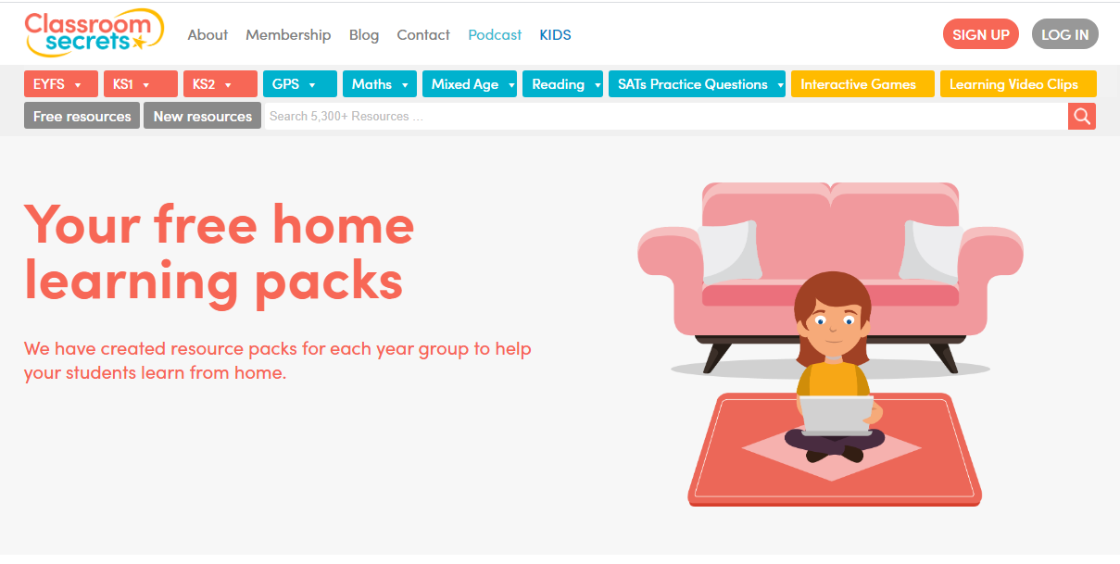

https://classroomsecrets.co.uk/free-home-learning-packs/

