Year 6 Home Learning
Writing  Make a poster, either on the computer or by hand, for the Year 5 children moving up to Year 6. What helpful tips can you give them about being a successful writer?  Reading  Read ‘The Cave’ extract. Answer the questions on page 1 for today’s home learning and those on page 2 for Wednesday’s home learning. Pay attention to the marks for each answer and try to allow your answers to be more detailed the higher the allocated mark is. The extract and questions are attached.  Spellings  Pick 5 words from the year 5/6 spelling list to learn. Can you think of a rhyme, saying or acronym to help you remember how to spell it?  Practise using those words in contexts. Write a sentence with them in and try to use a different English device in each sentence e.g. a semi-colon, brackets, dash, fronted adverbial etc…  Art  https://www.bbc.co.uk/bitesize/clips/zpnm4j6  Have a look at this BBC Bitesize video clip. It shows you how to draw a space picture using charcoal and an eraser. If you fancy giving it a go but don’t have charcoal, a pencil will work just as well. | 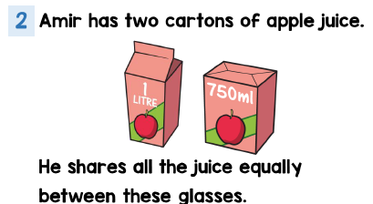  Maths  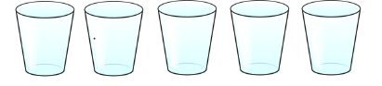  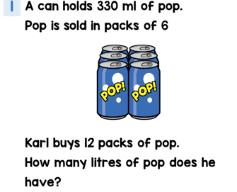  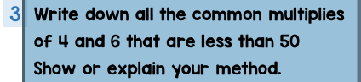  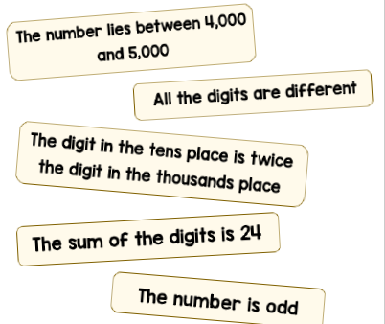  What could her number be?
Science

The following video clip revises how light passes through certain objects. Have a look at it and write a short paragraph, with labelled diagrams, to explain what you have learned.
https://www.youtube.com/watch?v=YuUJCNzfoBw

Mindfulness

Make a small hanging gift for us to hang from a Friendship Tree. When we go back to school, we will choose a tree on the field to place the items. Below is a picture of a Friendship Tree in Downley.
