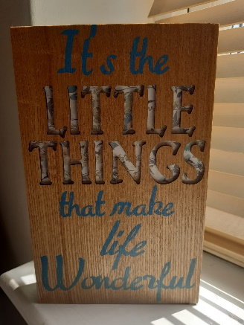
Lockdown Happiness/Thankful Jar

1. Find an old jar, box or margarine tub.

2. Make sure it’s clean! If not, wash with a little washing up liquid.

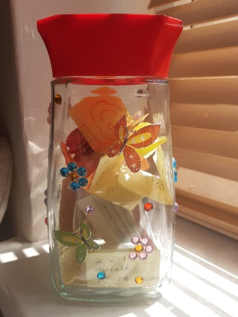
3. Decorate with stickers, pictures or coloured paper.

4. Decide if it will be your jar only, or one for the whole family.

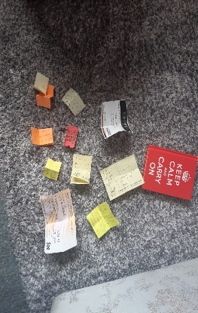
5. Add something you are grateful for. Try and do this every day.

6. You can add old tickets, memories, jokes or events if you wish. It's your jar so you can decide your own rules!

7. Still stuck for ideas?
How about whenever you tried a new food, made someone smile, went to bed without being asked or wrote a poem? Are you grateful for the sunshine, your pet, your family, your football team?

8. Have fun!!

9. Open the jar and look back on your ideas whenever you are feeling down.

10. Take a photo or tell the nurture team about it when we are all back together again!

