Year 4 Home Learning – Friday 3rd April 2020
We hope you enjoy completing these activities. If you wish to present the information in a different way, or to extend the activity, we would be delighted to see what you produce.
Remarkable Writing!  Poetry activity 3: Time to be a poet!  First, remind yourself of the original poem and your own version from earlier this week.  Now you are going to write your own list poem entitled Ten Things Found in …….  You need to choose your theme. Some ideas include:  A Shipwrecked Sailor’s Pocket  A Teacher’s Pocket  A Mermaid’s Palace  A Gnome’s Garden.  Or any of your own ideas!  Remember to think about your choice of nouns, adjectives, verbs and adverbs. You could also include one or two similes. Remember to write on a new line for each fresh line of your poem. | Resilient Readers!  Review a book you have read … we are looking for any well written reviews that we could send to Amazon, so your work could even be published!  A book review should include:  Title and Author.  A short summary of the type of book it is (you could use the blurb for inspiration, but do not simply copy it!).  What sort of book is it? Fiction (what type of story); non fiction.  Would you recommend this book? Why?  What age group would it be suitable for?  How many stars would you give it (out of 5)?  It’s important to be honest and keep it short, but the challenge is to make it interesting to read and ensure it helps the reader decide if this is a book they would like to try.
Super Science!  Watch the Reach Out Reporter clip and then discuss the questions below with someone in your family. https://www.reachoutreporter.com/news-update/images-of-the-sun-rainforest-life-and-a-space-hotel/  Rainforest Life  What do you find surprising about the animals recorded by Andreas Kay?  What does it mean to describe an area as “biodiverse”?  Why do you think it’s important to protect biodiversity – both in the Amazon, and closer to home. | Terrific Topic!  Use this Espresso link to investigate the Vikings further!  https://central.espresso.co.uk/espresso/priary_uk/subject/module/frontscreen/item1196013/grade2/index.html  You will find a variety of videos, activities (quizzes) and even some music to listen to.  Tell somebody in your household what you have found out. What surprised you? What would you like to know more about?  Without internet: create an illustration to go with your list poem. You could either create a border to the page you have written it on, or a separate illustration. Remember these are fun poems, so they need fun illustrations! Perhaps you could draw your character with huge pockets and then add the different things they have in their pockets!

Marvellous Maths!  Times Tables and division practice for quick recall.  Without internet: You could write them out, ask someone to quiz you or create your own beat the clock grid. Or you can use this link: https://www.topmarks.co.uk/maths-games/daily10  Fraction revision: Below is an activity which will revise various representations of fractions. Some questions require you to explain your answer.  Without internet: make a poster about fractions. Include vocabulary you can remember (e.g. numerator, denominator, unit fraction, non unit fraction, representation). Include examples and diagrams to show your understanding. Include fraction of shape and fraction of number. Challenge: include one or more word problems (with an answer sheet!). | Wonderful Wellbeing!  This week’s winning way to wellbeing is CONNECT.  Without internet: Do a kind deed for someone in your home.  Discuss the questions after watching Reach Out Reporter with members of your family. Share your ideas and thoughts and listen carefully to the thoughts of others.

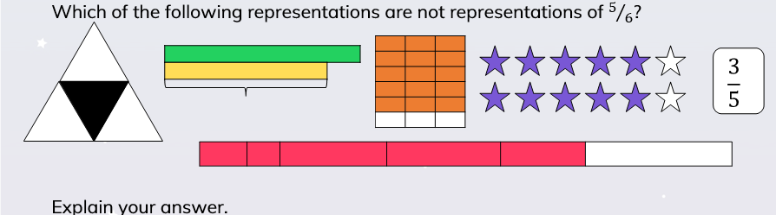
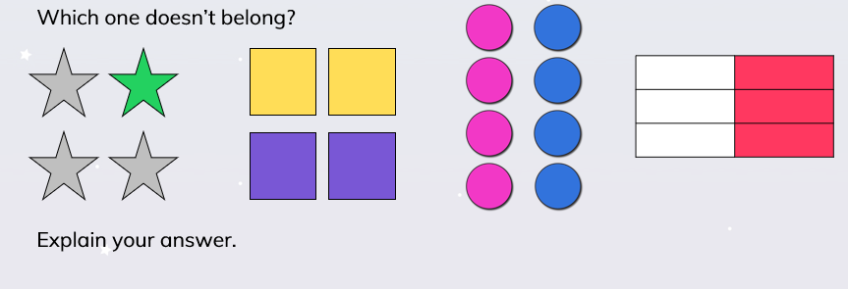
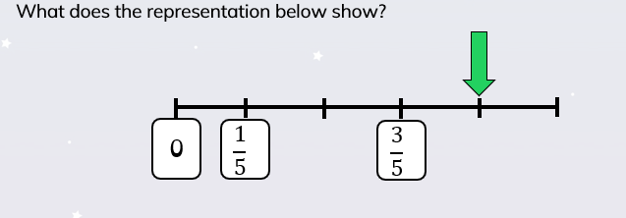
Different representations of fractions.

