Year 2 Home Learning
Week Commencing 8 June 2020- Friday
Please send your work to- year2@highworthcombined.co.uk
We always look forward to seeing your work. Please let us know if you need any help or have any questions.

English Task  Re- read your poem. Is there anything that you need to change? Have you used expanded noun phrases, adjectives, adverbs, alliteration, similes? Do you need to write it out again in your best handwriting? Make sure you illustrate your final poem with lovely pictures!  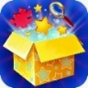  Listen again to the poem ‘The Magic Box’ by Kit Wright.  https://www.bbc.co.uk/bitesize/clips/zkpmhyc  How does he use tone and expression to capture the reader’s attention? Rehearse your poem. Can you learn it off by heart? Add actions and perform it to someone in your home!  Now perform your poem.  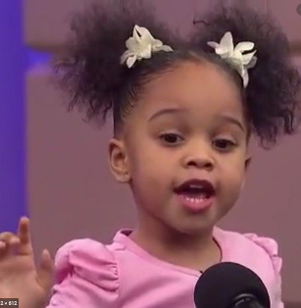  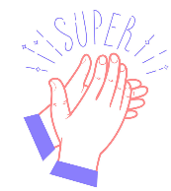  Have a go at recording it and then send us a video, if you can. | Art  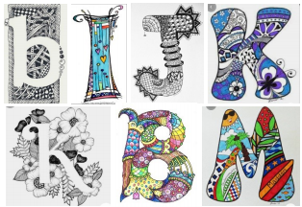  Create a piece of alphabet art using the first letter of your name.  Once you have drawn the letter you can either decorate around it, leaving the inside blank, or decorate the inside space. You can collage it or use pencils or paint.  Have a go at making a letter for each member of your family.
RE  Judaism  Here is a link to the Oak National Academy. It is one of the websites that provide online lessons. Most of these lessons start with a quiz at the start and then students complete the quiz again at the end of the lesson. Don’t feel you need to take the quiz at the start. If you fancy a challenge, have a go at the quiz at the end.  https://classroom.thenational.academy/lessons/why-did-moses-lead-the-israelites-out-of-egypt/activities/2  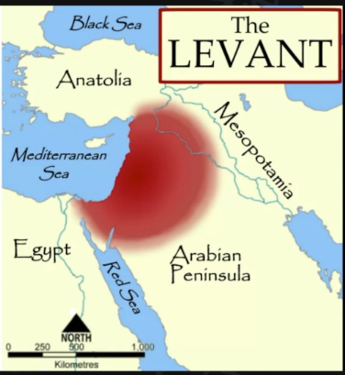  Lesson 2- Judaism - Why did Moses lead the Israelites out of Egypt?  In this lesson you will need to write a sentence to go with a prticular picture. Please send us a photo of your work at the end of the lesson. | Maths Task  Mental Maths Warm Up  1. 37 + 42 = __  2. 100 - 35 =  3. 2 x __ = 12  4. 25 ÷ 5 = __  Fractions  Please remember to show your workings.  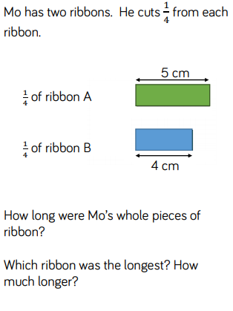  1.  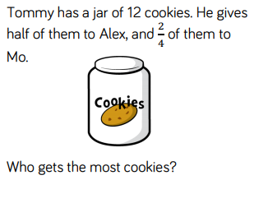  2.  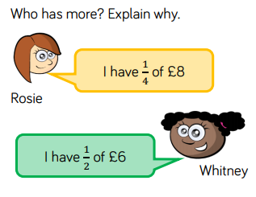  3.
Quiz Time  Have a go at completing at least two different quizzes and tell us how many you scored.  Tricky emoji quizzes  https://www.bbc.co.uk/cbbc/quizzes/bp-tricky-emoji-quiz?xtor=CS8-1000-[Discovery_Cards]-[Multi_Site]-[SL08]-[PS_CBBC~N~~O_EmojiQuiz]  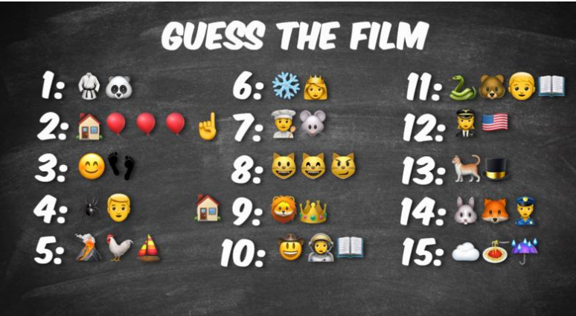 | Game Time  Small Town Superheroes  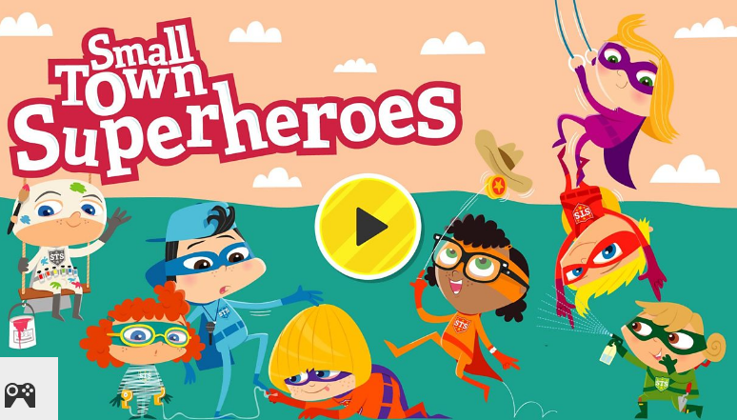  https://www.bbc.co.uk/bitesize/topics/zd63xyc/articles/zncgvk7  Follow the link.  Choose Punctuation, then click on Capital letters.

The Magic Box
I will put in the box
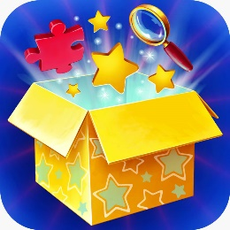
the swish of a silk sari on a summer night,
fire from the nostrils of a Chinese dragon,
the tip of a tongue touching a tooth.
I will put in the box
a snowman with a rumbling belly
a sip of the bluest water from Lake Lucerene,
a leaping spark from an electric fish.
I will put into the box
three violet wishes spoken in Gujarati,
the last joke of an ancient uncle,
and the first smile of a baby.
I will put into the box
a fifth season and a black sun,
a cowboy on a broomstick
and a witch on a white horse.
My box is fashioned from ice and gold and steel,
with stars on the lid and secrets in the corners.
Its hinges are the toe joints of dinosaurs.
I shall surf in my box
on the great high-rolling breakers of the wild Atlantic,
then wash ashore on a yellow beach
the colour of the sun.
by Kit Wright

