Home Learning Ideas for all
Wednesday 29th April 2020

Oti Mabuse Dance Classes
Oti Mabuse, from Strictly Come Dancing, has filmed many dance classes on her YouTube channel for children (and adults!) to learn. https://www.youtube.com/user/mosetsanagape/videos
You can learn to dance to songs from Hairspray, The Lion King, Frozen, The Greatest Showman and many more! I wonder if your dance could be filmed and sent in to us? We would love to see your dance videos!

Paper Towel Marker Magic!
This is a very simple but effective activity. All you need is kitchen roll, water, a plate and some washable markers/ felt tips. Fold a paper towel in half like a card. On the front of the paper towel card, make a simple design. Then inside, add more details and colours. Drop the paper towel into the water on the plate and watch the designs appear and colours spread!

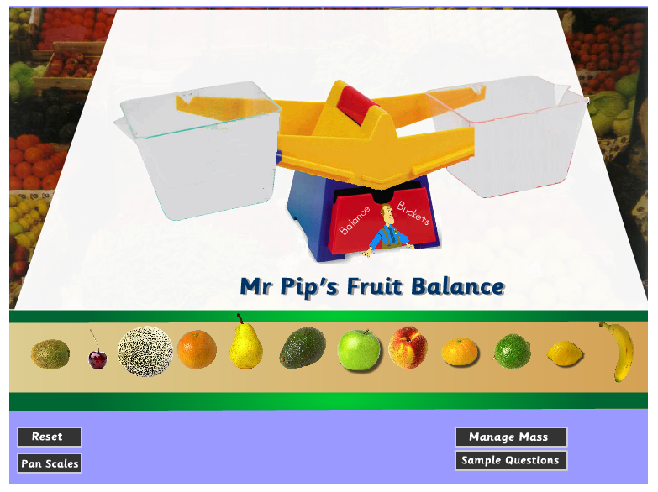
Crickweb online games
Crickweb has a wide variety of games for Early Years, KS1 and KS2. You will be able to find Maths and English games as well as Science, Geography and many more! http://www.crickweb.co.uk/

