Year 4 Home Learning – Monday 8th June 2020
Please email us your work to:
Year4@highworthcombined.co.uk
Thinking about the amount of rain the rainforest receives, we decided that we would link this to the water cycle.
REMARKABLE WRITING!

Watch the following clips that explains the water cycle. :
https://central.espresso.co.uk/espresso/primary_uk/subject/module/video_index/item1196044/grade2/index.html

https://www.youtube.com/watch?v=s0bS-SBAgJI

Using the information you have learnt, choose one of the following options to represent your information about the water cycle.
- Design a poster of the water cycle
- Make a cartoon strip of the water cycle, explaining the journey of a drop of water
- Write and perform a water cycle rap
Before you begin writing, Think about:
- The purpose of the writing you are about to complete? e.g. a poster text provides interesting facts.
- Similar texts we have used together at school to help you.
- Beginning by noting down your ideas including thinking about the structure you will use.
- Think about the vocabulary you will use - adjectives, adverbs, similes, alliteration, onomatopoeia, technical vocabulary
- How will you make this exciting for your reader?

WONDERFUL WELLBEING!  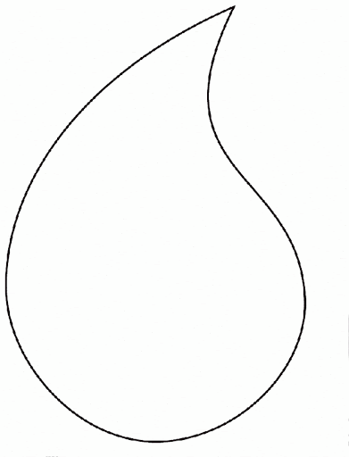  On a piece of paper, draw a large water droplet, then fill the droplet with interesting patterns. Once you have completed it you could colour it in or send a copy to us and we can attach it to one of the matrices for others to have a go at colouring it in. | SPLENDID SPAG!  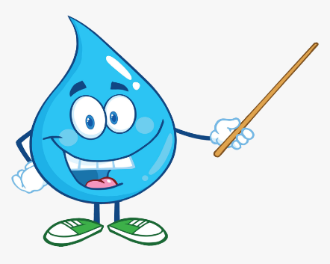  Time to pick up those colours and get ready to edit the given text. Complete the Save Our Water sheet, which is attached as a separate document with the year 4 home learning matrices.  You will need to think about:-  - capital letters  - full stops  - spelling  - past tense verbs
SUPER SCIENCE!

Water on Earth is recycled over and over again, it’s always moving. It is this recycling process that we call the water cycle. Today we are going to have a go at creating our very own mini water cycle model
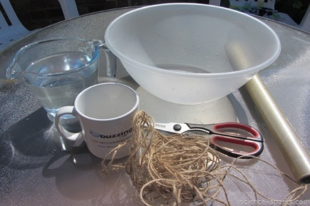
You will need:-
- a mug
- string
- cling film
- water
- a plastic bowl (mixing bowl size)

Method (this is best done outside in a sunny spot)
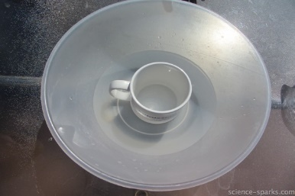
- Place the mug in the bottom of the bowl

- Add water around the mug so that it come up to 2/3rd of the mug – if you can draw on the bowl mark where the water level is.

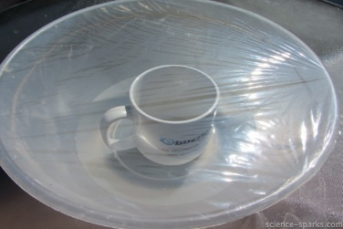
- Cover the bowl tightly in clingfilm and fasten in place with the string.

- Watch what happens!

- Write down the results, explaining what you observed.

- Challenge: Thinking about what you know about the water cycle, can you link what happened in this experiment to the water cycle and explain the process that took place. Remember to use the scientific vocabulary .
evaporation condensation precipitation

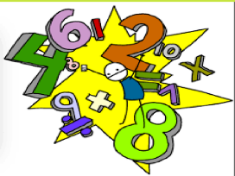
MARVELLOUS MATHS!

Keep going with your times tables and division practice, as well as practising other
mental maths skills like number bonds to 100 and rounding!
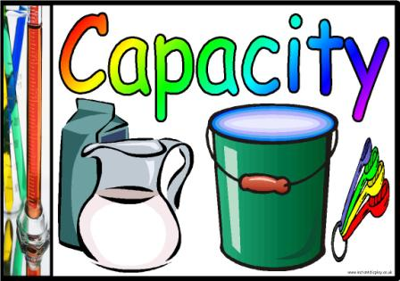

Capacity is the amount that something can hold. Usually it
means volume, such as milliliters (ml) or liters (l) in Metric,
or pints or gallons in Imperial.

- Complete the reading scales activity.
- For each of the cylinders, can you work how much more liquid could be
poured in so the cylinder reaches its capacity? (this link may help you to work out the intervals on the scales) https://www.youtube.com/watch?v=6JyDRJBJQgU

CHALLENGE: Clink on the link below. It will take you to the ‘Pouring Problem’. Follow the instructions and see if you can answer the question at the end.

https://nrich.maths.org/13664

