**Extra Home Learning – HID Children No 9 - Monday 15th June**

To replace some of the tasks in the class home learning you may wish to try some of these. Parents, please simplify or extend depending on needs and age of children. There’s more signing from Mrs Mills and a game from the Royal

Association of Deaf People – copy this link:

https://www.facebook.com/1019788514740928/posts/2979152368804523/?vh=e

Don’t forget to email me your child’s learning to [hid@highworthcombined.co.uk](mailto:hid@highworthcombined.co.uk)

|  |  |
| --- | --- |
| **Signed Story From Mrs Mills –**  **‘The Lighthouse Keeper’s Lunch’**    Watch the signed story and  then read the story on the  Power Point.  **There are activities to do**  **below.** | **Scientific Wordsearches:**  Some fun word searches related to the science topics you have been learning. See below for:   1. Yr2 – Light and Dark 2. Yr3 – Planting Seeds 3. Yr4 - Gravity   Can you remember the signs for the words on the word searches? |
| **From the Royal Association of Deaf People:**  **Caterpillar Racing Game –**  See the source image  Watch the recording of how  to make a racing caterpillar game.  Copy and post this link to get the  instructions:  https://www.facebook.com/1019788514740928/posts/2979152368804523/?vh=e  You need:  green card, pen, scissors and some straws  Can you write and draw the instructions? | **Looking and Thinking Activity –**  **‘Pedestrian Precinct’**  Look carefully at the picture below in a pedestrian precinct. Pedestrian means ‘for people’ and a precinct is an American word for area. You can see that no cars are allowed there as it’s an area for people only.  There are 2 quizzes below, A and B. Start with A and if you can, you can do B as well. |
| **HID Afternoon Activity**: - **Worries**    Think back to the discussion we had in HID Afternoon about  worries. We talked about what a worry is. Someone said that it was  something you could not stop thinking about. When you worry, it makes  your body feel different things. Draw a big picture of yourself in the  middle of a big piece of paper and inside your body draw what happens  to your body when you worry. Remember, there can be little worries or  big worries. Draw or write all the things that happen to your body  when you have little or big worries.  **Leave a space around the outside of your picture for next week’s activity.** | |

**See 7 more pages below:**

1. **Activities for story, ‘The Lighthouse Keeper’s Lunch’**
2. **Light and Dark Science Word search**
3. **Planting Seeds Science Word search**
4. **Gravity Science Word search**
5. **Looking and Thinking picture for ‘Pedestrian Precinct’**
6. **Questions A for ‘Pedestrian Precinct’**
7. **Questions B for ‘Pedestrian Precinct’**

**Activities for ‘The Lighthouse Keeper’s Lunch’ – see Power Point**

Cut up these words and put the sentences together:

|  |
| --- |
| Sentences for: The Lighthouse Keepers Lunch |
| In the daytime, he rode out to his lighthouse on the rocks. |
| When it rained, he worked hard. |
| As the basket went down the wire, the seagulls attacked it. |
| While Mr Grinling went to the lighthouse, Mrs Grinling made his lunch. |

Making a Sentence starting with a Triangle (When)

*Match the two parts of a sentence to make one big sentence. You can cut up the sentences and match them. Write the sentences out in your book.*

|  |  |  |
| --- | --- | --- |
| While the fisherman rowed his boat, |  | Mrs Grinling made his delicious lunch. |
| When the seagulls came again, | the seagulls took his lunch out of his basket. |
| As the fisherman caught a fish, | the cat sat on the lunch basket. |
| When the seagulls tried to steal the lunch, | the boat tipped over and the fisherman fell in the water. |
| While the fisherman was fishing, | the cat scared them away with her paw. |
| While Mr Grinling rode to the lighthouse, | the seagulls came and stole it. |
| When the dog jumped up at the seagulls, | the dog barked and barked loudly. |

**More to do:**

Draw a huge basket of your favourite lunch (you can paint or make one) and write what food you have put in your basket.

**2 – Science Light/Dark Word Search**

**m s c x o u t s i d e**

**w a v I n g v l h o k**

**o z b d f j l w p c l**

**d a r k v a x s a z i**

**a c e f w o a p t e g**

**h c r o t q g s h v h**

**s t r e e t l i g h t**

**c g b g l c v n a b s**

**d y h x p g a r d e n**

**shadow light**

**dark torch**

**garden path**

**streetlight**

**waving wall**

**outside**

**3 – Science- Planting Seeds Word Search**

**Plant some seeds-watch them grow-if you have no seeds try an apple pip**

**g r o w c w a t e r**

**e p a h s a q o g i**

**r a m g u r k n t s**

**m s x o z m r x m e**

**i t d v d t u z w v**

**n q w e e h o m e a**

**a k d n e u l w e e**

**t n a l p s o b k l**

**e b m q s j c u s k**

**h o a p p l e p i p**

**plant seeds**

**germinate grow**

**water warmth**

**apple pip leaves**

**colour shape**

**speed weeks**

**4- Science-Gravity Word Search**

**m g a l i l e o f n s**

**k r s l t k g b o d c**

**x a t u a z p j r s e**

**y v h p l a x e c t i**

**p i i c i o k c e h n**

**t t t s a m e t z g t**

**h y k o n m o y j i i**

**g e a r t h z h o e s**

**i x f a m o u s y w t**

**e l t n e r e f f i d**

**h q g r o u n d s f i**

**gravity force**

**pull object**

**earth galileo**

**italian scientist**

**famous different**

**weights hit**

**ground same**

**height**

**Picture for Looking and Thinking Activity: ‘Pedestrian Precinct’**

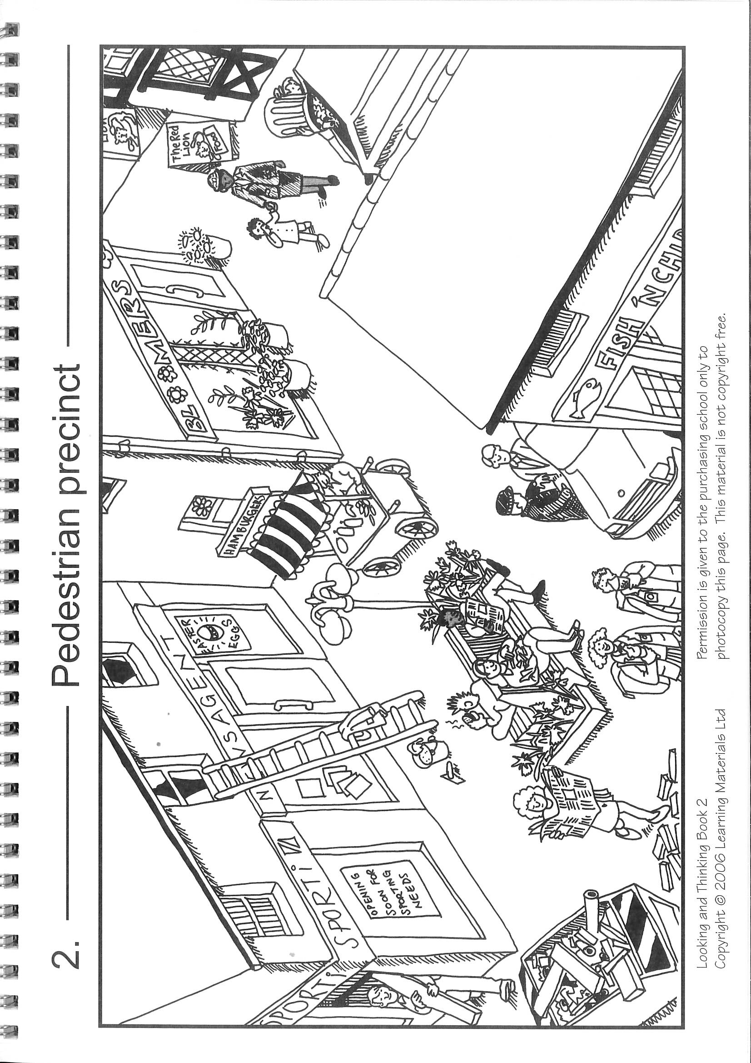

**See below for Questions A then Questions B for ‘Pedestrian precinct’**

**Questions A for ‘Pedestrian precinct’**

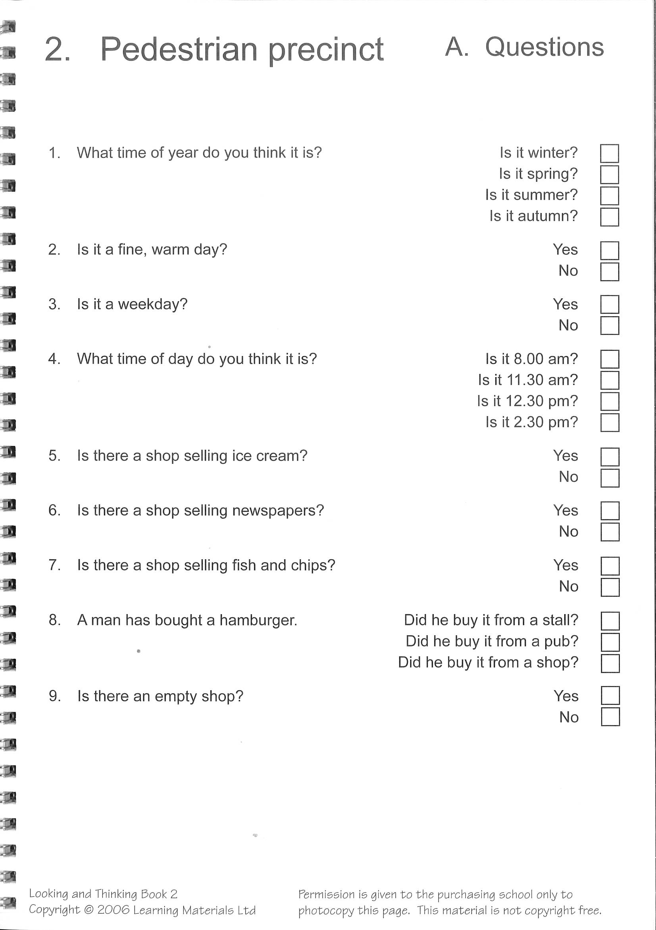

**Questions B for ‘Pedestrian Precinct**

