Year 2 Home Learning Week Commencing 30/03/2020 - Wednesday 1st April
Use the book sent home or a blank piece of paper to record your work.
Maths Task 3D Shapes  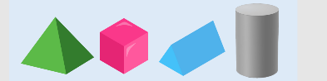  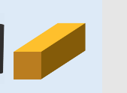    Name the following 3Dshapes  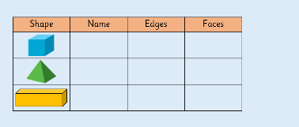  Now complete the table below.  You can continue the table for other shapes  Find examples of 3D shapes at home and draw a picture or take a photo of them. | SPaG/ Spelling  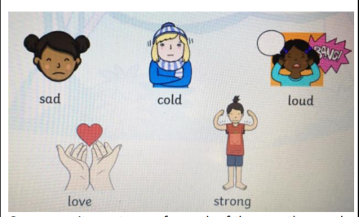  Can you make 5 new words by adding the suffix ‘-ly’ to end of the root word in each of the pictures shown below?  What kind of words did you make – nouns, verbs, adverbs or adjectives?  Can you write sentences for each of the new words ?
Science:  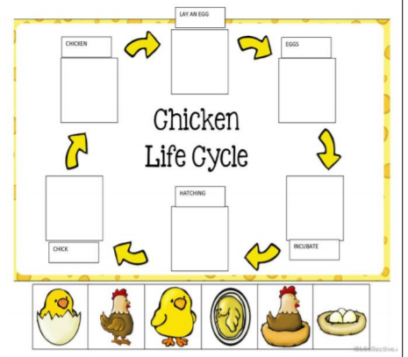  In Science, at the start of the year, we looked at the life cycles of humans. Can you create a lifecycle of another animal? For example:  You can also choose a life cycle of a ladybird, butterfly or a frog. | English Task  Using the picture prompt below, can you write your own creative descriptions including words that end with the suffix ‘-ly’?  For example: ‘Suddenly there was a frightfully terrifying noise…  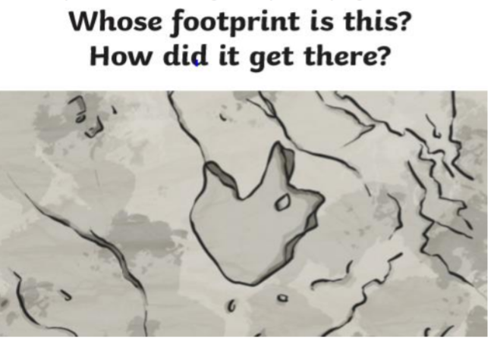  Can you now draw that creature ?
History  Read all the facts about the Great Fire of London, or visit  https://www.youtube.com/watch?v=Er3GKw8Z3R4  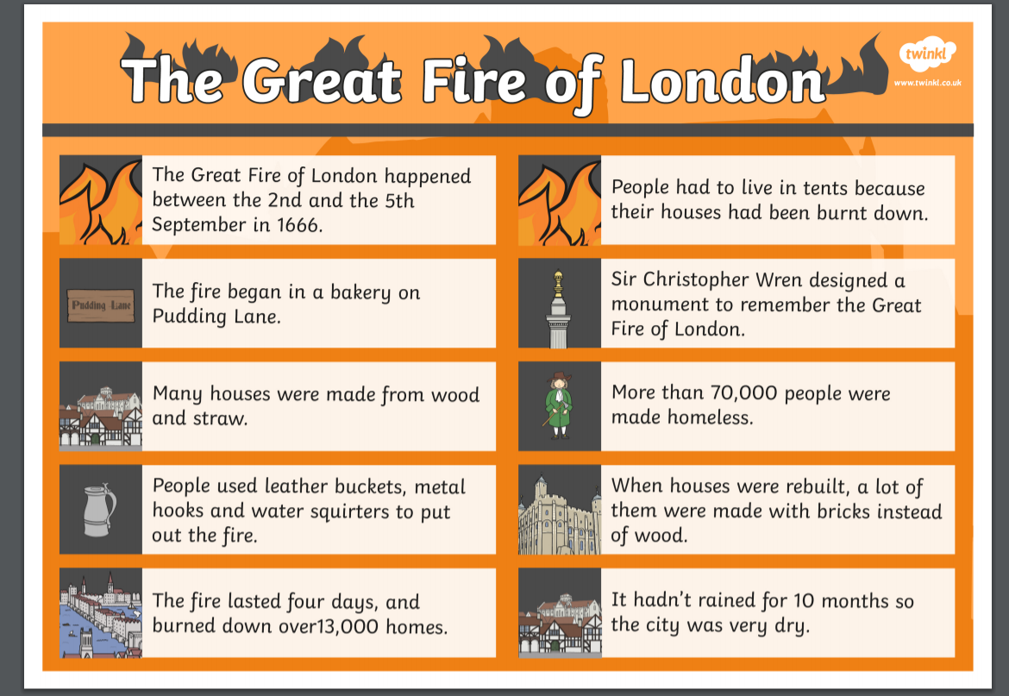 | App/ game  The Great Fire of London Game  http://www.fireoflondon.org.uk/game/

