Year 3 Home Learning – Wednesday 8th July 2020
X means that you do not need to have internet access or a printer to complete this task.
We would love to see examples of your home-learning, so please take photos and email them to us at year3@highworthcombined.co.uk It would be great to hear from you!
X – see below the web link  Amazing Art  Pop Art and Printing  Learn the basics of pop art and the printing technique used before having a go at creating your own pop art masterpiece.  Watch the videos, read the text and have a go at the activity.  https://www.bbc.co.uk/bitesize/articles/znw3hcw  X  If you do not have access to the internet, create your own piece of pop art in the style of Andy Warhol (see examples on page below).  Be imaginative - you can have green hair and yellow skin!  You could:  - use different coloured paper to cut shapes out  - create a print with lego, sponges or other objects in paint  - take a selfie, print it off 4 times in black and white and colour it in - make sure the details are still clear | X  Super Stories  Look at the picture attached below, and read the start of the story set in ‘Watchwood Forest’.  Can you continue Rose’s story?  Think about –  What did Rose see in the forest?  What happened to her?  Did she have to escape from something?  At the end of the story, did she learn her lesson and decide to follow the rules in the future?  Try to include:-  -noun phrases including adjectives  creepy, creaking trees  quiet, eerie sounds  green, glowing eyes  terrible, whistling noises  -punctuation – commas, exclamation marks, full stops and capital letters, ellipsis (…)  - fronted adverbials  Suddenly, …  As she turned around, …  In the distance, …  - paragraphs – remember to use a new paragraph for each new part of the story | Remarkable Reading  Visit Bucks library website https://buckinghamshire.overdrive.com/library/kids  to access online children’s reading materials and resources including eBooks, audiobooks and comics completely free of charge.  Also – why don’t you join the ‘Summer Reading Challenge’. Click on this link https://summerreadingchallenge.org.uk/home-zone-src  where you can find information about how you can take part in the Challenge.  The Summer Reading Challenge website is free to access and is a place for children to rate and review the books they are reading as they progress towards their reading goal.  The website features video content, games, quizzes and digital and downloadable activities.
The Science of Sound  Making different sounds  Follow this lesson on the Oak National Academy website to learn all about different sounds made by instruments and then have a go at making your own!  https://classroom.thenational.academy/lessons/making-different-sounds | X – see below the web link  Telling Time  Use the link below to learn how to tell the time to the nearest 5 minutes.  Work your way through each slideshow and then have fun practising what you've learnt with the two worksheets.  https://www.bbc.co.uk/bitesize/articles/zjf4ydm  X  If you do not have access to the internet, practise telling the time with an adult using a clock at home.  Can you read the time on a clock for when you do these things:-  - when you get up in the morning  - when you sit down to watch your favourite tv programme  - when you have lunch  - when you have dinner  - when you go to bed | X  Amazingly Active  PE activity - Stepping stones  Set up a start line (use 3 markers in a row - this could be small cones, tins from the cupboard or chalk on the pavement) and a finish line.  How many different ways can you hop, skip and jump through the markers to the finish line?  For example:  hop, skip, jump  hop, skip, hop …and so on.  Challenge: What about if you have 4 markers?

Andy Warhol prints

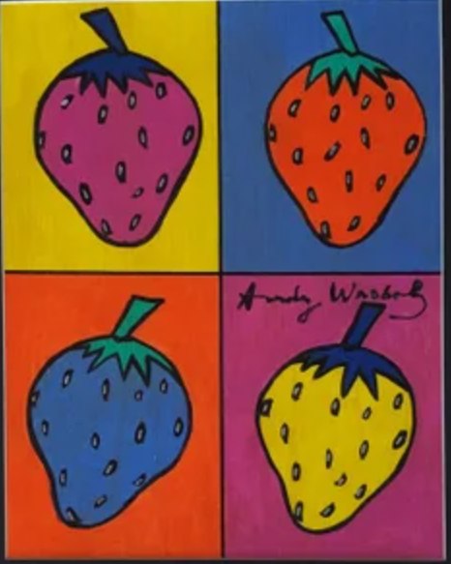
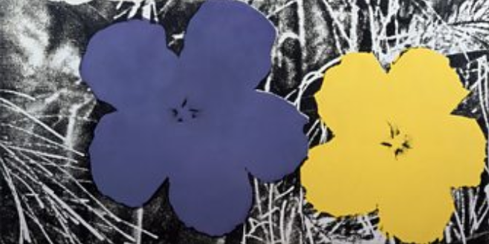

Super Stories – Watchwood Forest
