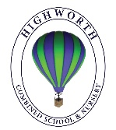
Year 1 Home Learning – Wednesday 6th May 2020

Below, you will find 6 home learning tasks. You may choose the tasks that you wish to complete and do them in any order. Please do not hesitate to contact us if you have any queries or would like to share the work you have been doing.
year1@highworthcombined.co.uk
Julia Donaldson is a famous author, a number of the activities are based around her stories today. With an adult you can access and watch some of her stories that have been made into films on this link. https://www.bbc.co.uk/iplayer/group/p06vkmht. Perhaps you could let us know which your favourite story is!
English  Today we are learning about adjectives. Adjectives are words that describe a noun.  E.g. The scary, huge Gruffalo went for a walk.  Scary and huge are adjectives in the sentence because they tell us what the Gruffalo was like.  Copy the sentences below and write the adjectives in a different colour.  The brown mouse was hungry.  The witch is wearing a spotty skirt.  I saw a big, green bird flying.  The happy, little girl was banging her drum loudly.  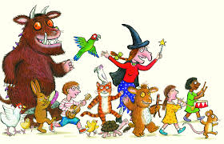  Can you write your own sentences to describe the characters above and include a range of adjectives..  Adjectives can come before or after the noun, try putting your adjectives in different places to make your writing more intersting. If you want to describe your noun in more detail you can use more than one adjective and if you have a list of them you can separate them with a comma.  - Challenge- Find your favourite book and copy a passage from it , when you have written it out colour in as many adjectives that you can find. | Science  Superworm  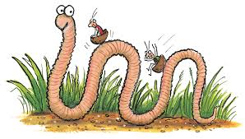  Today we are learning about habitats. Habitats are a home environment for plants and animals. Habitats can be big or small. A habitat can be as big as an ocean or as small as a flower pot. We are going to think about the habitats for small insects and bugs today because they are very important.  We need insects and bugs to pollinate flowers. This can be done by the wind, but it’s usually done by a range of insects. The most well-known of these is bees, but a surprising number of other insects also do this – some moths, flies, beetles, butterflies and wasps. The habitats that insects like usually have lots of tiny hiding places and food to eat, so that they don’t get eaten by birds.  A bug hotel is made by humans to give insects and bugs a safe place to live.  We would like you to make a bug hotel. You can use anything a bug can crawl into. Use any materials that you can find, think carefully about the sort of habitat insects and bugs would like and leave your bug hotel somewhere that is easy for bugs to get into.  Please take a photo for us to see your bug hotel.  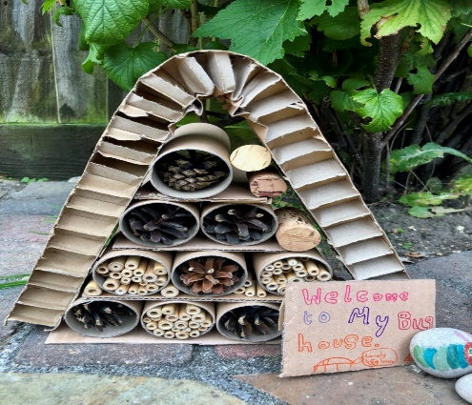  - Challenge- Can you find out more about the natural habitats that different insects and bugs live in and make a fact sheet?
Maths
What the ladybird heard
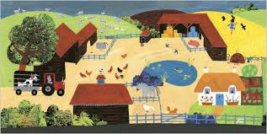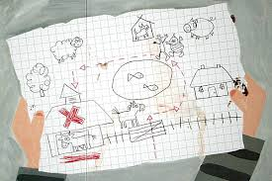
During the autumn term we learnt about position and directions. We learnt the words full, half and three quarter turns.
- Stand up and ask an adult to give you instructions e.g. Can you turn a three quarter turn, half a turn, a quarter turn , a whole turn etc. ( but don’t get dizzy from doing too many full turns in a row)

- Now draw this triangle on a piece of paper
- Then draw what it will look like once it has turned a: quarter turn, half turn, three quarter turn and full turn.
We also learnt the words left, right, forwards and backwards to describe position and direction.
- Draw a grid, like the one below.
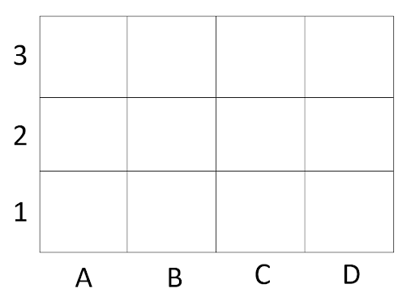
- Now draw in separate squares on your grid a farm house, a tree, a cow, a ladybird, a pond, a sheep, a dog in a kennel, a pig, a barn and Mrs Hawes’ chickens.
- Place a small toy on your grid and give an adult directions to move your toy from the farmhouse to Mrs Hawes’ chickens. Make sure you use directional words left, right, forwards, backwards, quarter turn, half turn.
- Repeat this activity starting from the farmhouse but this time going to the cow. (Make sure you don’t fall in the pond, bump into the tree or walk into the kennel you will need to direct the toy around these objects.)
Wellbeing  Stickman  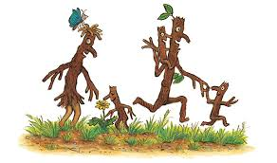  In the story the stickman, stickman is away from his family for a while. When stickman was away from his family he and his family felt worried and anxious about being apart and the changes in their lives and routines, and it is very normal to feel worried or anxious when things are different.  That is very similar to many of us at the moment who are unable to see people we know from school.  So today we would like you to write a reply to the class letter we sent to you last week. Read the letter carefully and think about how you could reply.  In your letter you could include:  - How you are feeling at the moment?  - Any worries or concerns you want to share with them?  - How you feel about staying at home?  - What you have been doing at home?  - Ways that help you feel calmer and happier.  - Activities you have been doing such as reading, playing, painting or cooking.  - What things you would like to do in the future with them?  - Anything else you want to tell to them about (and it is always nice to receive a cheerful picture).  Write your reply. Remember to write in full sentences and to start with ‘Dear …….. and end with ‘from………..’.  Challenge: Write a letter to someone in your family. | Art and Design Technology  Gruffalo  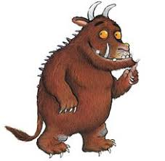  The Gruffalo has knobbly knees and turned out toes and a poisonous wart at the end of his noise. His eyes are orange, his tongue is black, and he has purple prickles all over his back.  Please read the description of the Gruffalo above and then make your own Gruffalo, it can be a drawing, painting, model, collage you can make him any way that you like.  Don’t forget to send us a picture of your art if you can!  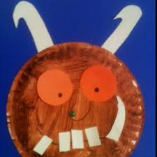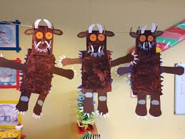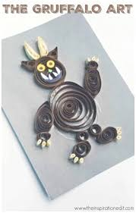  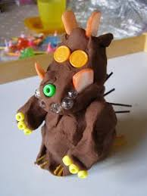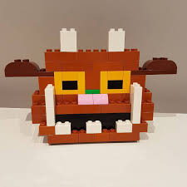
Geography
The snail and the whale
If you haven’t read the story this is the film version you could watch to help you with this task.
https://www.bbc.co.uk/iplayer/episode/m000cslw/the-snail-and-the-whale
In the story, the snail and the whale visit many places, they go to towering icebergs with penguins, to fiery mountains and golden sands, they go to where there are rocky mountains and bears and to a seaside bay. Where in the world do you think these places could really be? Can you name three countries that you think these places could be in?
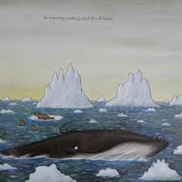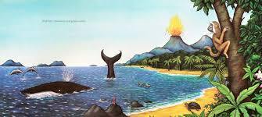
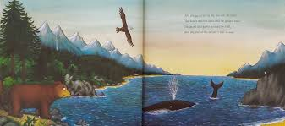

If you were the snail where in the world would you ask the whale to take you?
Choose one of the places from the pictures above or choose a country that you would like the whale to take you to. Find out a little more about it.

Here are some good places to look on the internet to help you find out about different places and countries around the world that the snail and the whale visited:
https://www.bbc.co.uk/bitesize/topics/zyhp34j
https://www.bbc.co.uk/iplayer/episodes/m0007z03/go-jetters

Make a poster about the country you have chosen. Things you could include:

- Facts you have learnt about the country you have chosen to find out about.
- The name of the country, and where it is in the world, what is its flag and what you would see there?
- What the place looks like, and features of the country.
- Drawings of animals or landmarks from that country.
- The continent it is in.
- Photographs of any places you have been.

If you can, send us a picture of your poster!

