Year 6 Home Learning
Writing  Similes are used in our speeches and even in our daily conversations in order to make explanations more understandable and words more vivid and powerful.  A simile is a figurative device that gives you the ability to compare the similarities of two different things. In using this figurative device, you have to use the words like and as.  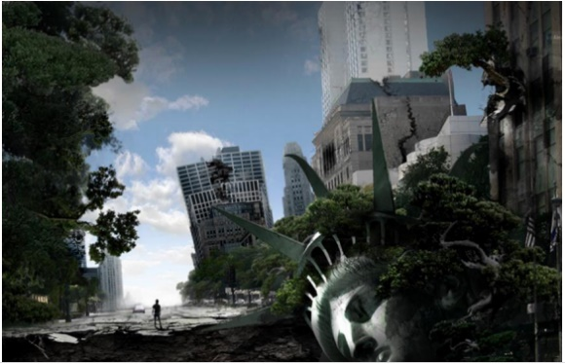  Look at the picture below. Write as many similes as you can to describe the different things you see. You can also think of the other senses (smell, touch, taste, feel).  Try to use strong similes. You can use the internet to research them if you like. For example, if you want to describe a tree, type into Google, similes to describe a tree and it will give you some amazing ideas. Good luck! | Maths  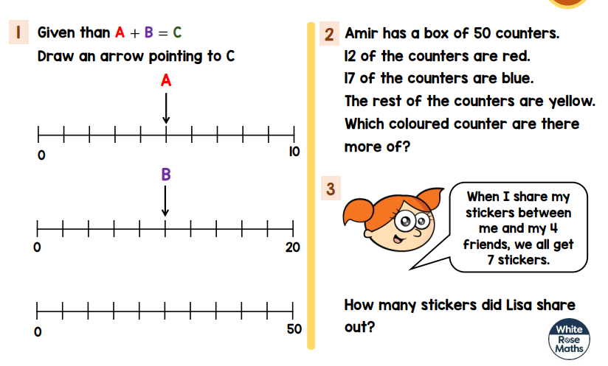  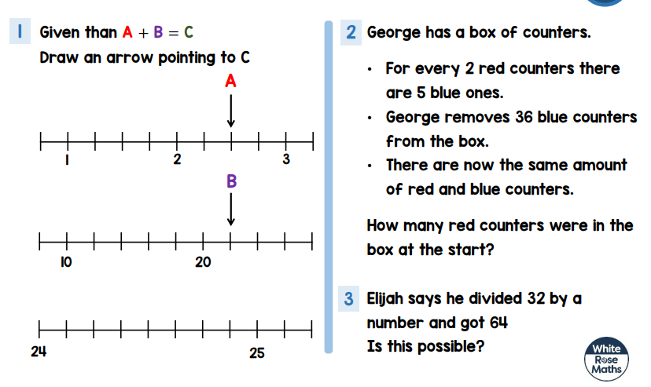  Useful website to revise our WW1 topic  https://www.thenational.academy/online-classroom/year-6/foundation/#subjects
Reading  Read the extract attached.  What impression do you get of Harry from the first 4 paragraphs? Give one impression and support your answer with evidence from the text.  Impression = think, feel, opinion | Science  Last term, we learned about animals and plants that live in extreme environments and how they have adapted to survive there. We studied how the camel can cope with a desert habitat. I would like you to change the camel’s habitat. It does not live in the desert anymore but the Arctic. How might it look? What features might it have? How will it adapt to this oppoasite extreme? Draw a picture of the new species of camel and label it to explain how it happens to suvive in this cold place. I’m really looking forward to seeing these so impress me!! Virtual green cards may be on the way!!
Spellings  Pick 5 words from the year 5/6 spelling list to learn. Can you think of a rhyme, saying or acronym to help you remember how to spell it?  Practise using those words in contexts. Write a sentence with them in and try to use a different English device in each sentence e.g. a semi-colon, brackets, dash, fronted adverbial etc… | Mindfulness  Find a quiet space where you won’t be interrupted. Spend 5 minutes concentrating on your breathing, listen to the birds and try to imagine your worries floating away down a river. Attached is a really helpful meditation practice called Tummy Ride. I will practise it too. Perhaps we could compare notes and let each know how we get on.

