Week 7 Home Activities 1 of 3

Here are some suggested activities you could complete as a family. They are linked to our Early Years Foundation Stage Curriculum and current learning. Have fun and keep well!
Literacy/Communication  Please watch video on Oak National Academy, where the children can listen to the story ‘Whatever Next’ by Jill Murphy and afterwards use their imagination to go on a journey…  www.thenational.academy/reception/foundation/bored-reception-wk1-1#slide-2  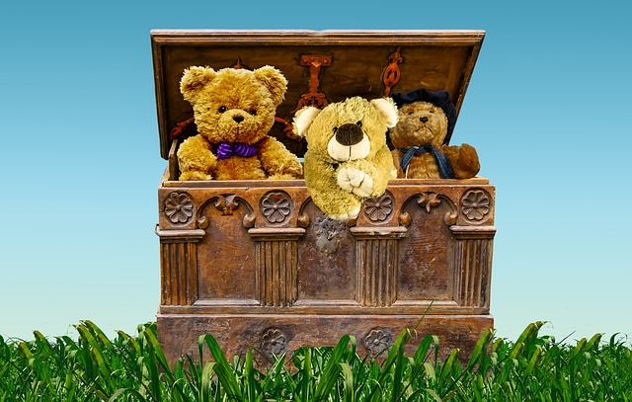 | Mathematical Development  Make a shape picture. Cut out some shapes out of paper and arrange them to create pictures and patterns.  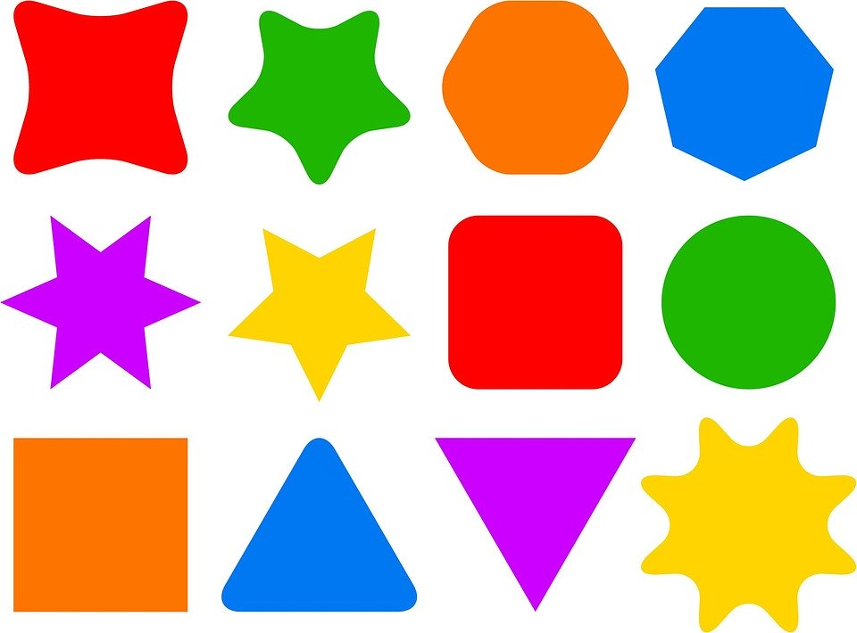 | Knowledge and Understanding of the World  Put some seeds of the ends of things eaten (carrot tops) into water and see if you can grow.  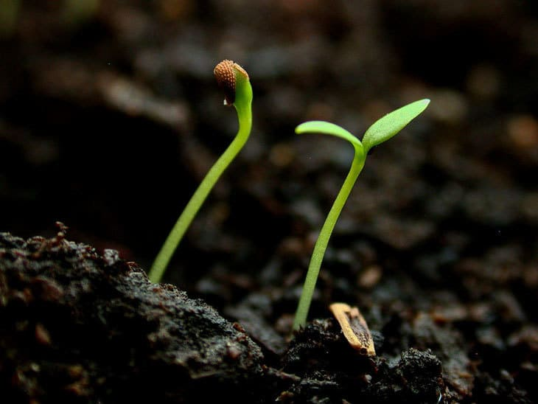
Physical  Can you fold strips of paper to make paper caterpillar? Can you make family of caterpillars (differ length).  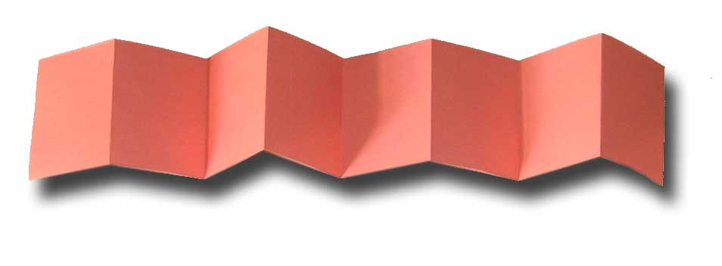 | Personal and Social  Can you make a bubble?  Put a little washing up liquid and water on a plate and mix in the centre. Put a straw onto the plate and blow! Who can blow the biggest bubble?   | Creative  Please watch the video on Oak National Academy where the children can sing/dance along to the song ‘I can sing a rainbow’  www.thenational.academy/reception/foundation/rainbow-song-and-dance-reception-wk2-3#slide-2  

