HID Children Transition Week - Monday 13th July

Dear Parents,
This is the last week of the school year. All teachers and staff are at school getting ready for September and this week children can too at home. Don’t forget to go on the Website on Wednesday to find out who their new teacher will be and do the Transition activities given by their new class teacher. Below are some activities for children to do during Transition Week to help them with transition and some things can be added to the activities set by their new teacher on Wednesday. There is an end of year signed story from Mrs Mills and a Power Point as well. Thank you for all your hard work over lock down, have a great holiday and I look forward to seeing everyone in September.
Don’t forget to email me your child’s learning to hid@highworthcombined.co.uk

What to tell your new teacher:  Think of the things that have helped you last year. Your new teacher does not know about it. Write, draw or sign what you would like to tell her.  Think about:  - Things you need to help you understand what the teacher is saying  - things you use in class to help your work  - people who help you in class  - other people you work with in HID | You can draw pictures, write a letter or make a poster. You can sign it and record it and send it to me. You can add your ideas to a letter to your new teacher.  For example:  - wear a radio aid, look at me when you speak to me…, I need signing  - I need my Word Book for English  - I need my communicator to sign to me  - I need to go to HID to see Ms Pereira, Mrs Haines, Mrs Mills
My Chat Book.  Make a little booklet with a title page ‘My Chat Book.’ In the booklet I would like you to put in all the things you would like to tell me.  When we start school in September, I will chat to you about the things in your booklet.  We will talk about:  - Your holidays  - What you found out about your new teacher and class on Wednesday 15th  - What you look forward to in September  - Questions you have  - Your feelings or anything you want to tell me or show me | You can draw pictures,  take photos, write  about your holidays,  questions or what you  what you are thinking  about. You can decorate  your book.  Examples of things you could do or write:  - A picture of me playing outside  - My new teacher’s name and my new classroom  - A picture of my friends I will see in September  - Who will work with me?  - I did not like lock down because…
End of Year Fun Book.
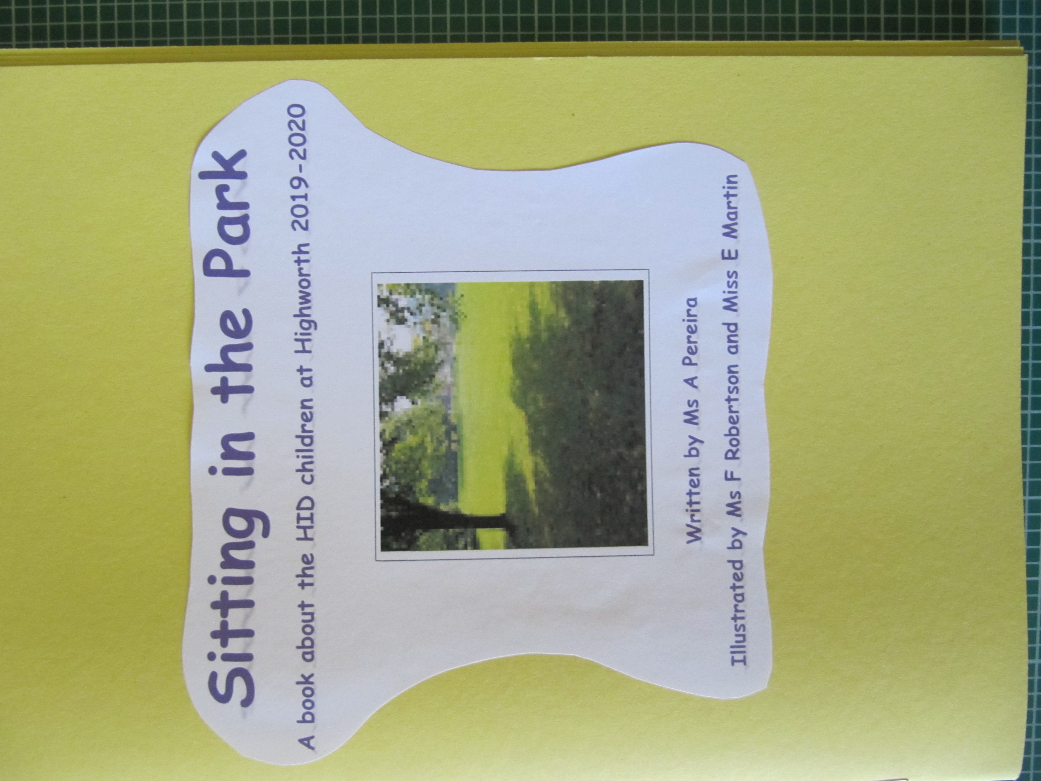
I have written a poem about all of you in HID. Watch
it signed by Mrs Mills and read it on the power point.

Activity:
Guess who the children are in the book. Can
You find out what you are doing in the poem?

There is an end of year message for everyone
at the end.

