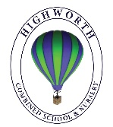
Year 1 Home Learning – Wednesday 25th March

We hope you are all safe and well at this unusual and difficult time. Below, you will find 6 home learning tasks. You may choose the tasks that you wish to complete and do them in any order. Please do not hesitate to contact us if you have any queries.

English  Over the last few weeks, we have learnt the story of ‘The Magic Porridge Pot’ and have worked as a class to change the story to ‘The Magic Milk Jug’ (1LM) and ‘The Magic Candy Floss Maker’ (1H).  Write your own magic story based on the stories we have written as a class.  Have you used full stops, capital letters, finger spaces and your phonics knowledge?  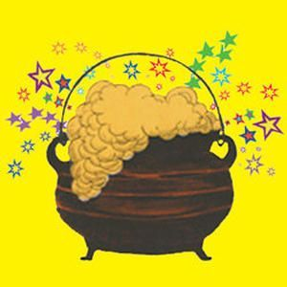 | Maths  Using items from around your house, make a ramp for a selection of toys.  Estimate the distance that each of your toys will travel.  Then, test your toys down the ramp.  Measure the distance your toys have travelled. If you don’t have a ruler can you use another household item to measure the distance e.g . Pasta shapes, buttons etc.  - Which toy travelled the furthest?  - Which toy is the nearest to the start?  - Can you record your results?  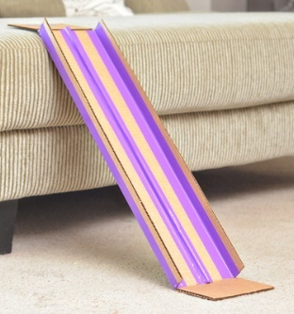  - What could you do to make the toys travel further?
Art
Ask an adult to help you find the artwork called ‘Sunflowers’ by Van Gogh, ‘Water Lilies’ by Monet and ‘Surprised!’ by Henri Rousseau. Which do you like the best and why?
Using art materials you have at home make your own picture of something from nature e.g. flowers, animals, woods, jungles etc. You could use crayons, pens, paints, collage or even make a 3D artwork using junk modelling materials or something different.
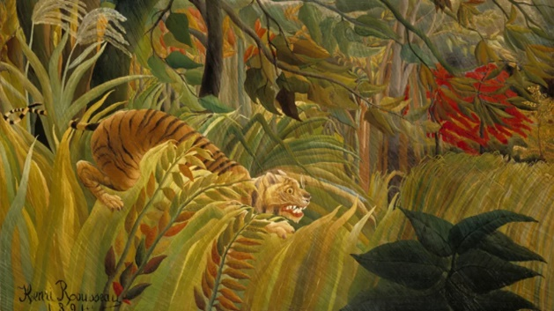
We would love to see some photographs of your work!
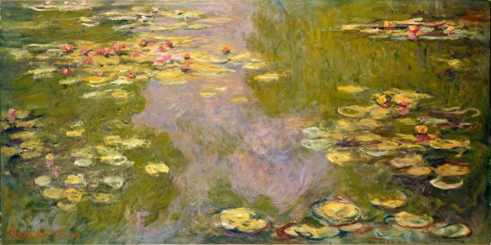
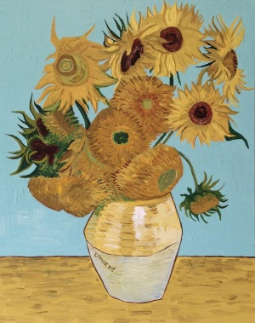

Science  Draw a large map of the United Kingdom. Add any cities and places that are important to you e.g. High Wycombe, London, where you have been on holiday or where a family member lives.  Make your own weather symbols and attach them to your map with blue tac or something similar.  Now pretend to be a weather person and talk about the weather in the different parts of the United Kingdom.  What would the weather be like in the summer, autumn and winter and how is it different from now?  https://www.twinkl.co.uk/resource/t-m-338-weather-forecasting-role-play-pack  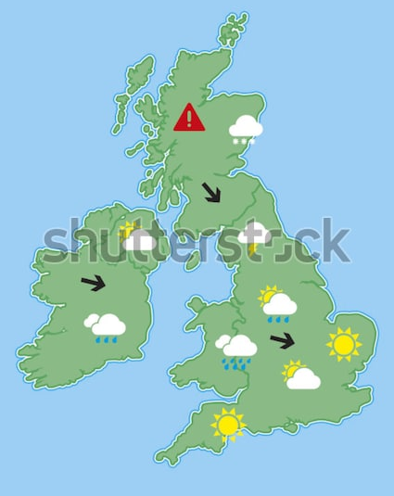 | Geography  Draw a simple treasure map.  Ask an adult or older brother or sister to place a small toy on your map and give them directions to get to your treasure.  Can you use words like left, right, clockwise, anti-clockwise, full turn, half turn and quarter turn when giving directions?  https://www.twinkl.co.uk/resource/t-t-27715-create-your-own-treasure-map  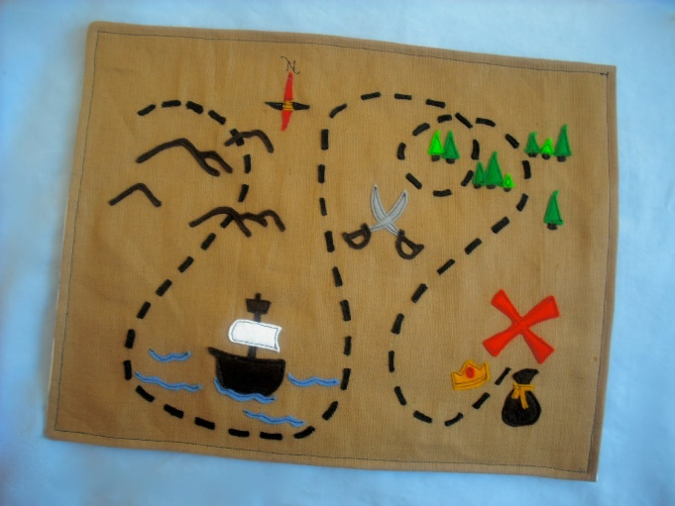
History
Using two pieces of paper, write ‘NOW’ on one and ‘THEN’ on the other
On the piece with ‘NOW’ on draw the sorts of activities that you like to do at the weekend or at the end of a school day. Add labels and captions about your pictures.
Next talk to your parents or grandparents and find out what they used to do at the weekends or after school.
On the other piece of paper with ‘THEN’ written on, draw your parents/grandparent's activities and label them.
Can you write a sentence about the similarities and differences?