Year 3 Home Learning – Monday 6th July
We would love to see the work you have been doing. If you would like to take a picture of your work and send it to us for feedback, our email address is year3@highworthcombined.co.uk
Reading – make sure you spend some time reading every day, 10 minutes minimum.
Maths – Year 3 Times tables practise  Complete the multiplication wheels below to practise your quick recall of times tables facts.  The times tables we need to learn by the end of Year 3 are the 1 x, 2 x, 3 x, 4 x, 5 x, 8 x and 10 x tables.  I have left in the 6 x , 7 x, 9 x, 11 x and 12 x tables as I know a lot of you have been learning those as well. | English – Emma’s Puppy Problem  Read the short text ‘Emma’s Puppy Problem’ below.  Read it through at least twice before you answer the questions about it.  Make sure you check back in the text for the answers to the questions instead of trying to just remember the answers. | English – Revise subordinating conjunctions  Look at this work on BBC Bitesize. It is revision on how to use subordinating conjunctions to add more detail to your writing and to write longer sentences.  https://www.bbc.co.uk/bitesize/articles/zxqgn9q  Complete the activities, including Activity 3, and try to write sentences that include a subordinating conjunction at the start of the sentence, as explained on BBC Bitesize.
Science – Roll and Draw Plant Game  Have a look at the information below on how to play a dice game that will help you learn the names for parts of a plant.  Play the game with someone in your family.  Below are some definitions for parts of a plant you may not know. | Music – Make music with found objects  Have a look at this lesson from BBC Bitesize about how to make music with objects from your house.  - https://www.bbc.co.uk/bitesize/articles/znt8bqt  Watch the videos and try making your own music! | Art – Magazine collage  Use some old magazines or comics to cut up to make a collage.  Choose small pictures that you like, cut them out carefully and arrange them onto a piece of paper.  Arrange the pictures carefully before you stick them down. You can use a mixture of small and large pictures to make your artwork more interesting. Look at the examples below.
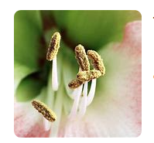The stamen produces pollen in a flower. 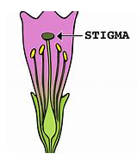The stigma receives the pollen

