Year 5 Home Learning – Wednesday 10th June 2020
We’d love to see your work! Please send it to: Year5@highworthcombined.co.uk
ENGLISH  We are going to start a new piece of writing on the ‘Wonderful World of Wizards!’.  Scroll down for the worksheets. You will have to create some wizard ‘Top Trumps’ cards and read the advert. Have fun!  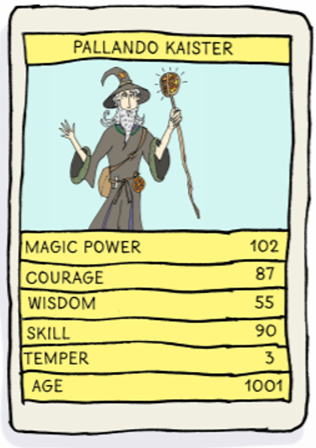  http://www.toptrumps.com/how-to-play-top-trumps/ |  | MATHS  LONG MULTIPLICATION  Scroll down for questions to practise multiplying 3-digits by 2-digits.  Remember to align the digits according to their place value and use a 0 place holder when multiplying by the tens digit.  The answers are included so, when you have finished, you can mark your work.  If you have any incorrect answers, look back over your work, check your calculation and see if you can spot your mistake.
WONDERFUL WORDS
Look at the Year 5 & 6 Words List. You can find it as a link on our Coronavirus Closure, Home Learning Matrix, Year 5 tab: https://www.highworth.bucks.sch.uk/web/year_5/460996
Choose 4 or 5 words to practise at a time.
- Look up the definition in a dictionary to check the meaning of each word.
- Learn the correct spelling by using: Look, Say, Cover, Write, Check.
- Write a sentence which includes the word to show that you understand its meaning.
4. Challenge yourself to include a RELATIVE CLAUSE in each of your sentences. Scroll down to the
REVISION CARD for a reminder about them.
RE  Buddhism  We are continuing our lessons on Buddhism.  Click on the link below to complete lesson 2:  https://classroom.thenational.academy/lessons/what-is-the-sacred-text-of-buddhism | READING  Challenge!  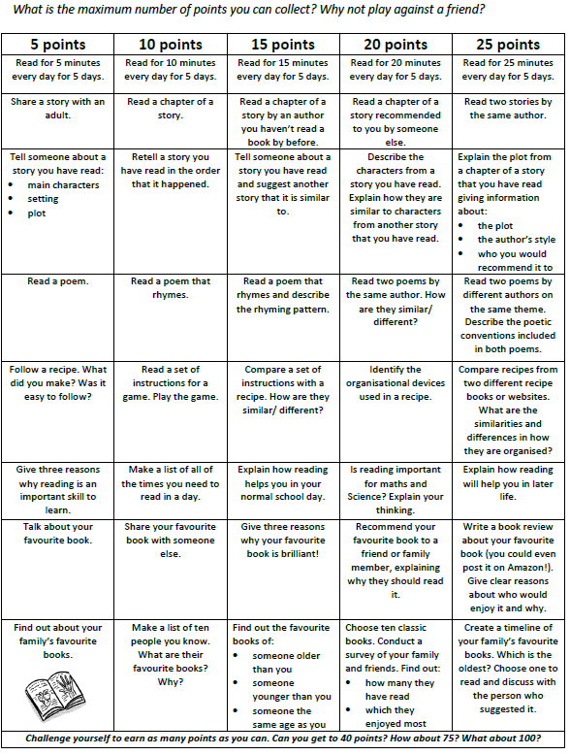  Scroll down for a clearer copy of the challenge.  Start today and challenge yourself to get as many points as you can in a week. Good luck! |  | ART  ORIGAMI  Some of you attended Mrs Kern’s origami classes and everyone tried some origami in class.  Why not have a go at this origami challenge?  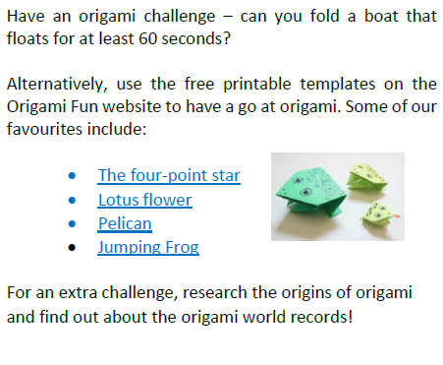  We have attached the instructions for the four- point star to get you started. (it is a bit tricky so you will have to persevere and ask for help if you’re stuck.)  https://www.origami-fun.com/printable-origami.html

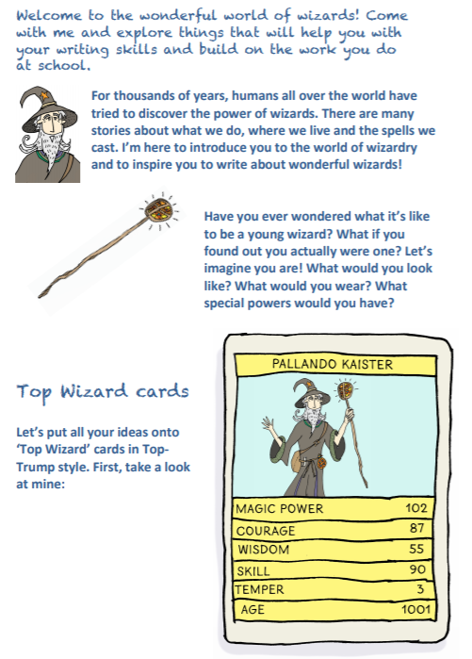
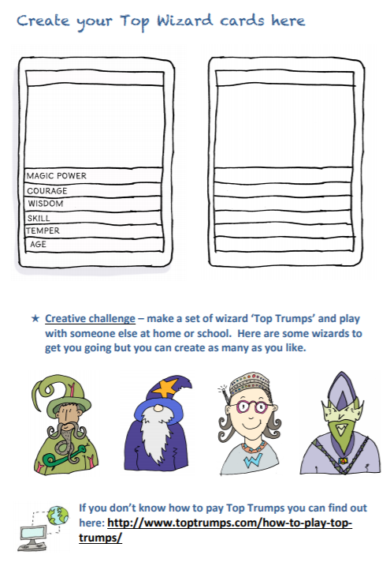

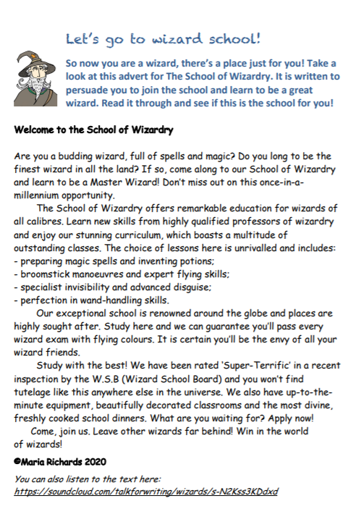

LONG MULTIPLICATION
Remember that ‘multiplicand’ is a quantity which is to be multiplied by another.
e.g. 54 is the multiplicand in the calculation 54 x 32 = 1728

