Year 6 Home Learning
Please email your work into us using the Year 6 email address – year6@highworthcombined.co.uk
We love hearing from you and seeing everything you’ve been up to! Take care Year 6.
Writing – Time Capsule Week  This week, you are going to be creating a time capsule to capture life in lockdown during the week beginning 18th May. The teachers are going to do this too and share theirs with you on our return back to school!  Please see the attached guidance and work through the activities each day.  Wednesday 20th May – consider the ways that you’ve stayed connected during the lockdown.  Thursday 21st May – write a diary entry to reflect upon the changes in the way you learn. There are some prompts in the guidance but make sure you use these to help structure your paragraphs.  Have fun! | Maths  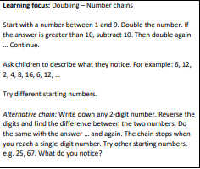
Reading  Before we broke up, we started learning about the Civil Rights Movement in History. Have a read of the attached comic strip about Martin Luther King from the National Geographic website.  Chose a key figure from the cartoon to complete some further research on and present your findings. This could be in the form of a mind map, a newspaper article on them, a biography or an information text.  Don’t forget that this is a useful website for research:  https://www.researchify.co.uk/  ** We are publishing the answers to the comprehension today so please use them to self-assess your work. Let us know any questions you don’t understand!** | Topic  Continue to use the oak national website. Have you learnt anything in addition to what you already knew? We’d love to see or hear about this!  https://www.thenational.academy/online-classroom/year-6/
Spellings  Sentence challenge.  This will really make you think. Get someone in your family to pick a selection of words from the spelling list (the more words you pick, the harder the task will become). Can you try and use all of the words in a sentence that makes sense?  Be creative and think of ways you could extend your sentences through additional phrases, clauses and punctuation e.g. relative clauses, semi-colons, brackets and dashes etc… | Mindfulness  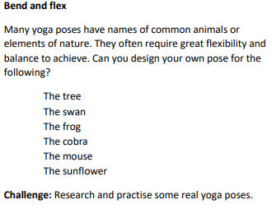  Send us in some photos of your yoga poses!

