Year 5 Home Learning – Friday 24th April 2020
ENGLISH  One day you find this door at the corner of your room. What do you do? Who uses that door? Where does it take you? Will you meet someone new? How does it end?  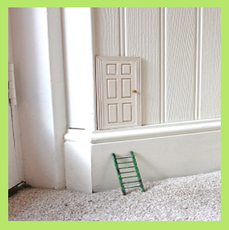  Write a story using this picture and your answers as a prompt. Include direct speech, adjectives to expand your noun phrases and lots of detail to entertain your reader.  Remember to check and edit your work for correct punctuation and spellings, in a different colour pen if possible. |  | MATHS  Can you remember how to multiply and divide by 10, 100 and 1,000?  Complete the worksheets below (scroll down). There are three to choose from but you could do them all!  If you get stuck, this will help you:  Move the digits to the left when you multiply a number.  Move the digits to the right when you divide a number.  The number of places that the digits move is determined by how many 0 place holders there are in the number that you are multiplying or dividing by.  So: to multiply or divide by 10 move one place; to multiply or divide by 100 move two places; to multiply or divide by 1000 move 3 places.  For example:  What is 64 multiplied by 10; by 100; by 1000?  64 64 64  Answer: 640; 6,400; 64,000  What is 572 divided by 10; by 100; by 1000?  572 572 572  Answer: 57.2; 5.72; 0.572.
WONDERFUL WORDS
Look at the Year 5 & 6 Words List. You can find it as a link on our Coronavirus Closure, Home Learning Matrix, Year 5 tab: https://www.highworth.bucks.sch.uk/web/year_5/460996

Choose 4 or 5 words to practise at a time.

- Look up the definition in a dictionary to check the meaning of each word.
- Learn the correct spelling by using: Look, Say, Cover, Write, Check.
- Write a sentence which includes the word to show that you understand its meaning.
4. Challenge yourself to include an EXPANDED NOUN PHRASE in your sentence.
SCIENCE  There has been lots of news about the Starlink satellites that were launched into space by Elon Musk.  Can you do some research on these satellites and find out what their purpose is?  You can watch some of the videos of the rocket launch (with adult supervision).  Can you write down a few facts about this project?  Why don’t you design your own rocket? | PSHCE  We have done lots of work on E-safety at school.  Can you create a poster to remind yourself, and your family members, of how to stay safe on the internet? |  | DT  We are certain that you will find out some interesting facts about satellites and rockets.  Why not use recycled materials to build your own rocket model? You can use the research you did in Science to help you plan your design.  We look forward to seeing your creations!

In addition to the tasks above, please remember to spend 10 minutes reading every day!
