Remarkable Writing!  Today, we would like you to have some fun creating a comic strip. There is a format below but feel free to create your own.  First you need to create your own superhero and then use them as the central character in your comic strip.  Think about:  A name for your superhero.  What will they look like? What will they wear?  The problem your superhero is going to solve.  Any special powers your superhero has that will help him or her.  Pictures as well as words.  Including some speech bubbles.  Great vocabulary including onomatopoeia (eg. smash, bang zoom!).  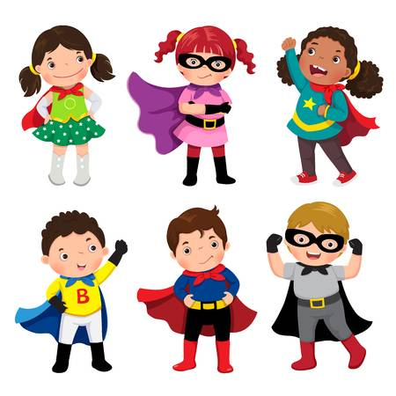  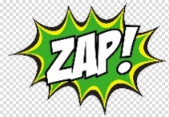 | Sensible SPaG!  Common Exception Words – those tricky words that you just have to know how to spell!  List the following words and check that you have copied each word correctly. Make sure you use neat joined handwriting.  calendar  caught  centre  century  certain  circle  Fun ways to learn include:  Create rainbow words. Write the word in one colour, then use another colour (not quite over the top of the first one!) and so on).  Now write some silly sentences using at least two words in each sentence.  Challenge: create a wordsearch of common exception words. Remember to include a list of the words that are included. Send it to us and we could try it!  We have attached a word search made by Freya last week for you to try!
Super Science!  Have you ever wondered what makes a paper plane fly? Some paper planes clearly fly better than others. But why is this? One factor is the kind of design used to build the plane. In this activity you'll get to build a paper plane and change its basic design to see how this affects its flight. There's a lot of cool science in this activity, such as how forces act on a plane so it can fly. So get ready to start folding!  On the attached sheet you will find the instructions for today’s experiment. Try it out and record your findings.  CHALLENGE: Try and investigate one of the following. Write up your experiment, remembering fair testing.  - Do bigger planes fly farther?  - Does the type of paper affect the distance a paper plane flies? | Terrific Topic!  On Monday, we suggested you could make a recycling monster. Can you add a new feature to your monster today? Perhaps he or she will have a special power?  Linking to our wellbeing focus to keep active this week, we would like to begin to create a lockdown dance routine.  You need to remember to keep it fairly simple so that you can remember it and so you could easily teach it to someone else. You might want to include repeated sequences eg for a song’s chorus.  You can choose any song or music and the dance does not have to be for the whole song!  Good luck and have fun!
Year 4 Home Learning – Wednesday 29th April 2020
Marvellous Maths!  Times Tables and division practice for quick recall. You can use this link: https://www.topmarks.co.uk/maths-games/daily10  Don’t forget you can use Daily 10 to practice other mental maths skills too! Let us know about any you have tried and how you got on. You could also try some different mental maths activities online such as Hit the Button or Mental Maths Train (both are free via Topmarks website).  Without internet: You could write them out, chant them walking around or up and down the stairs (exercise too!), ask someone to quiz you or create your own beat the clock grid. Can you create a rap / song / poem to help you practice any times tables you find more tricky?  Short multiplication  Using a dice, cards or by making your own 0-9 digit cards, generate a two or three digit number. And select a single digit number. Find the product of the two numbers. Try this a couple of times.  3  7  5  e.g. number 1 is 67  number 2 is 4  to find the product : 67 x 4 =  6 7  X 4  2 6 8  2  You can use this clip to remind you, if you have access to the internet.  https://www.khanacademy.org/math/arithmetic/arith-review-multiply-divide/arith-review-multi-digit-mult/v/2-digit-times-1-digit-example-no-carrying  Challenge: What calculation could you do to check your answers?  Now check your answers. | Wonderful Wellbeing!  This week’s winning way to wellbeing is:  Be Active  Below are cards numbered 1-6. Use a dice and roll it (If you don’t have a dice, you could make 1-6 cards or jot the numbers 1-6 down randomly on a piece of paper and dot a number.) Complete the activity on the card that has the corresponding number. Try this a number of times. You could even get others in your house to do it with you, each taking turns.  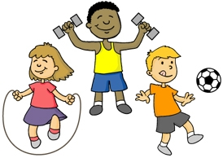  High knees for 20 seconds  Touch every door in your house  Do 20 arm circles  Do 10 arm circles  Do 10 star jumps  Do 5 star jumps  Please continue to complete the Ramadan Wellness calendar you started last week.
We hope you enjoy completing these activities. If you wish to present the information in a different way, or to extend the activity, we would be delighted to see what you produce. For all Twinkl resources and access to Espresso, please refer to the log on details under the Home Learning Ideas on the school website. If you have access to the internet or iPlayer, remember that you can find lots of useful activities and mini lessons on BBC Bitesize. Oak National Academy is another great website.
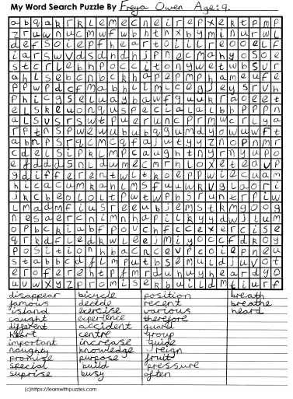
Paper Planes

Materials
• Sheet of paper
• Ruler
• Scissors
• Large open area in which to fly a paper plane, such as a long hallway or your garden. If you're flying your paper plane outside, try to do it when there isn't any wind.
• Something to make at least a starting line, such as a long string, another ruler, masking tape, rocks or sticks.
Preparation
• Make a standard, "dart" design paper airplane (use the instructions on the next page or watch this clip to help youhttps://www.youtube.com/watch?v=V-rBmbBSGlA )
• Fold carefully and make your folds as sharp as possible, such as by running a thumbnail or a ruler along each fold to crease it.
• Go to a large open area and, mark a starting line. This will be the line from which you'll fly the paper plane.
Procedure
• Place your toe on the starting line and throw the paper plane. Did it fly very far?
• Throw the plane at least four more times. Each time before you throw the plane, make sure it is still in good condition (that the folds and points are still sharp). When you toss it, place your toe on the line and try to launch the plane with a similar amount of force, including gripping it at the same spot. Did it go about the same distance each time?
• Once you have a good idea of about how far your plane typically flies, change the plane’s shape to increase how much drag it experiences. To do this, cut slits that are about 2 ½ cm long right where either wing meets the middle ridge. Fold up the cut section on both wings so that each now has a 2 ½ cm wide section at the end of the wing that is folded up, at about a 90-degree angle from the rest of the wing.
• Throw your modified paper plane at least five more times, just as you did before.

How far does the paper plane fly now compared with before?

Why do you think this is, and what does it have to do with drag?
