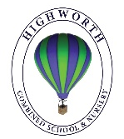
Year 1 Home Learning – Wednesday 1st April

Below, you will find 6 home learning tasks based on ‘The Very Hungry Caterpillar’ by Eric Carle. Use the link below to see a video of the story on YouTube:
https://www.youtube.com/watch?v=75NQK-Sm1YY
You may choose the tasks that you wish to complete and do them in any order. Please do not hesitate to contact us if you have any queries or to send us any of the work you have been doing.

year1@highworthcombined.co.uk
English  Over the last term we started to look at and learn a range of traditional tales and popular stories, and we have also been learning to spell the days of the week and numbers in words e.g. one, two, three, four etc. We are going to combine these today and write our own version of ‘The Very Hungry Caterpillar’.  In ‘The Very Hungry Caterpillar’ he eats something different on each day. Write your own version of the story but change it to ‘The Very Hungry Child’ and each day choose a different food for your character to eat.  Have you used full stops, capital letters, finger spaces and your phonics knowledge, did you spell the days of the week correctly, did you learn to write the number names?  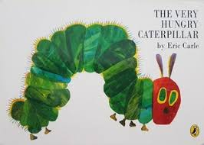  Can you write your days of the week and months of the year correctly? ask a grown up to check your spellings. | Maths  In the story ‘The Very Hungry Caterpillar’ the caterpillar eats foods in numerical order to start with e.g. one apple, two pears, three plums.  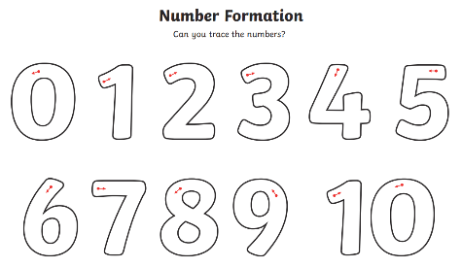  Cut up lots of squares of paper, and on each piece of paper write a digit starting from 0 going up as far as you can. Make sure you form 0-9 correctly.  Then, mix your pieces of paper up and ask a family member to hide them around your house. Find your number cards and place them in order.  - Can you write your numbers to 100?  - Can you read and write numbers from 0-20 in numerals and words?  - Ask an adult to pick a number, can you tell them the number that is one more or one less than the number they have given you?
Design and Technology

In the story ‘The Very Hungry Caterpillar’ the caterpillar eats a range of foods.

Help a grown up to make a meal today. If you aren’t sure what to make you could have a look in a recipe book you have at home or ask someone in your family what their favourite meal is. Write the list of ingredients you will use, the method and maybe photograph or draw what your final meal looks like. Don’t forget about food hygiene, and the importance of helping to clear and tidy away at the end of your cooking session.

- Wear a clean apron.
- Wear closed-in shoes to protect your feet, in case of hot spills or breakages.
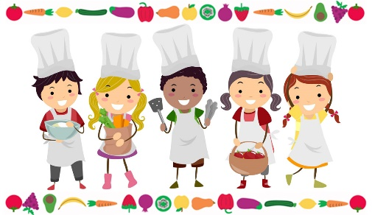
- Wash your hands before and after handling food.
- Keep food preparation surfaces clean.
- Tie back long hair.
- Wash vegetables and fruit under cold water before use.
- Do not run around the room where food is being prepared.
- Wipe up food spills immediately.
- Don’t use any cooking equipment or appliances without adult supervision.

Challenge
- Did you make a healthy meal? How do you know?
- Do you know where in the world the different ingredients you used have come from?
- Do you know how the different ingredients have been made?
- Which ingredients were grown?
- Can you find out about different food groups?
Science  In the story ‘The Very Hungry Caterpillar’ the caterpillar hatches from its egg, eats lots of foods and grows bigger, forms a cocoon and finally turns into a butterfly. This is the very basic life cycle of a butterfly.  https://www.twinkl.co.uk/resource/t-t-5147-butterfly-life-cycle-video-powerpoint  Draw some caterpillar eggs, a caterpillar, a cocoon and a butterfly, then place them in order to represent the life cycle of a butterfly. 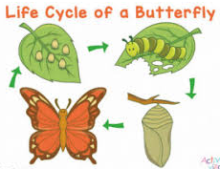  Challenge  A butterfly offspring looks very different to an adult butterfly.  Can you draw some other animals and their offspring that look different when they are young to an adult and write a sentence to show the similarities and differences (e.g. ladybird, frogs/tadpoles , goffin cockatoos, giant pandas, tapirs, swans, emus, silver leaf monkeys, flamingos, echidnas) | Geography  https://www.bbc.co.uk/teach/class-clips-video/science-ks1-ks2-wonders-of-nature-monarch-butterflies-in-habitat/zvjd7nb  Watch the clip of the Monarch butterfly.  Find out where the monarch butterfly usually lives and colour these parts in on the world map below.  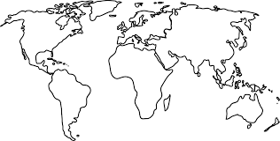  Challenge  - Can you name the countries that the monarch butterflies are usually found?  - Can you name the continents that the countries are in?
Art
The start of ‘The Very Hungry Caterpillar’ starts with the sentence ‘In the light of the moon, a little egg lay on a leaf.’
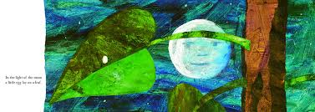
Have a look at the famous artwork below. Which do you like the best and why?
‘The Starry Night ‘  by Van Gogh | ‘A Landscape with a River at Evening’  by Aert van de Neer | ‘Sunset at Ambleteuse’  by Theo van Rysselberghe.
Using art materials you have at home, make your own evening time picture. You could use crayons, pens, paints, collage or even make a 3D artwork using junk modelling materials or something different.

We would love to see some photographs of your work!

