Year 4 Home Learning – Monday 11th May 2020
Today is …
Please email us your work to:
Year4@highworthcombined.co.uk
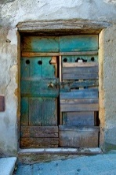  Remarkable Writing!  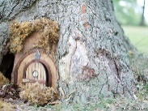  3 doors … which would  you choose? What  mystery does each door  hold?  Look carefully at these 3 different doors (you can see bigger pictures below!).  Choose one of the doors as your inspiration to begin your writing. You could write:  - A setting description – what is beyond the door? Can you introduce a character too?  - A story – include a beginning (setting, characters), middle (explore the mystery through action and adventure) and ending (be imaginative and try to avoid happily ever after!)  Remember to think about …  Capital letters and all punctuation. Spelling.  Paragraphs.  Vocabulary choices.  Sentence openers  Varying sentence length to create suspense.  EDITING! | Resilient Readers!  In line with our Mystery Monday theme, you are going to read an extract from a book about a very famous fictional detective …. Sherlock Holmes!  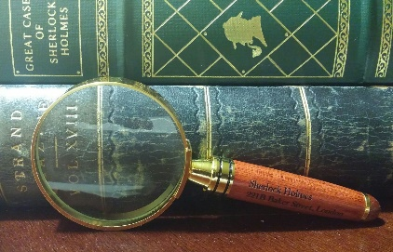  You will find the text and questions as a word document under the Home Learning Matrices tab for today.  This will help you practice different types of questions:  - Retrieval (find the answer in the text)  - Vocabulary  - Sequencing  - Inference
Wonderful Wellbeing!  Please continue to complete the Ramadan acts of kindness calendar you started.  This week’s winning way to wellbeing is:  Today we would like you to take time to read to someone at home. It could be a section of the book you are reading, a poem or a page from a comic or magazine that you enjoy. Please discuss aspects of what you have read with the other person.  You could:  - discuss the vocabulary you thought was effective.  - What you liked or disliked about the text and why.  - What you think might happen next.  - Your favourite character and why?  (the options are endless) | Terrific Topic!  You are going to try some orienteering, with a mystery theme to find some treasure!  Choose something to hide (treasure). It shouldn’t be too big and you need to hide it in secret!  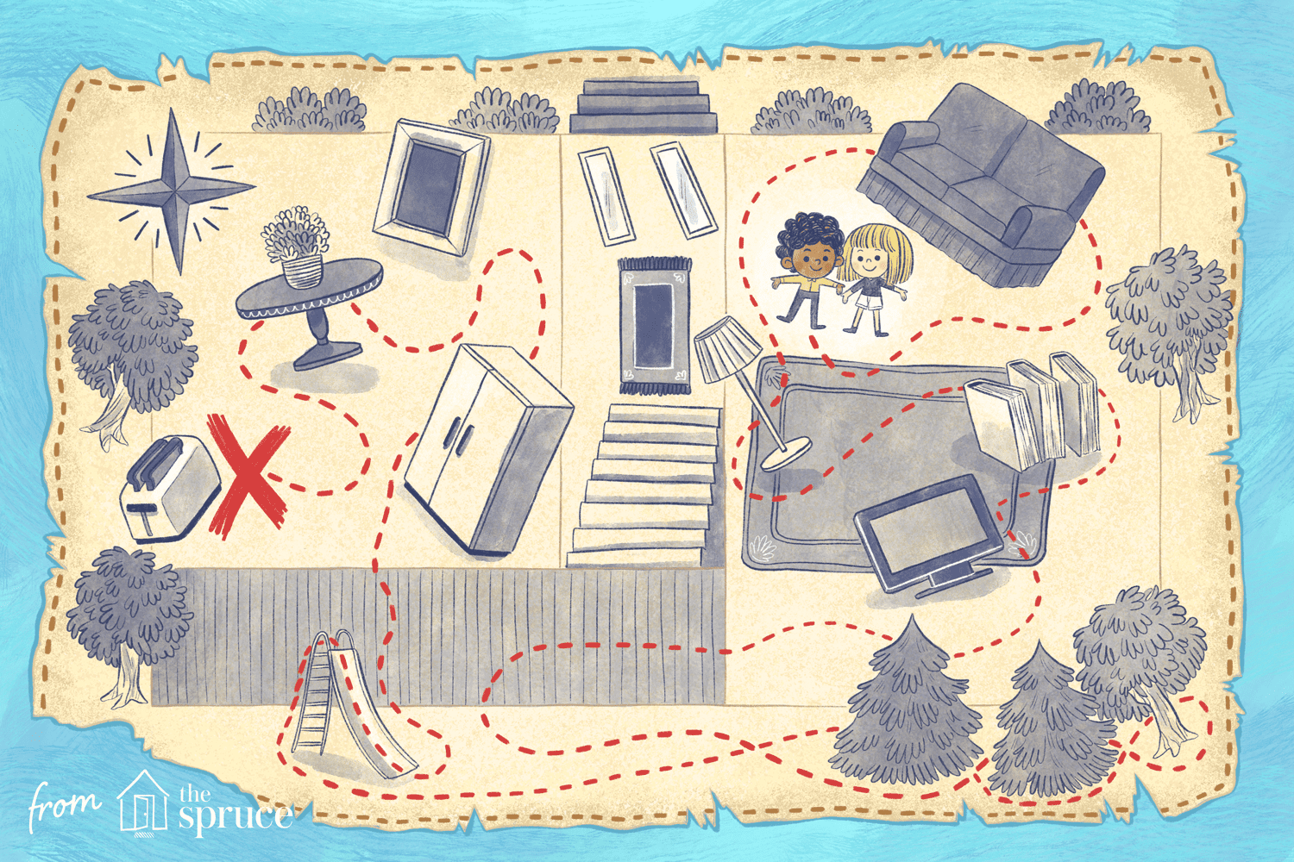  You are going to create some clues for someone in your house to follow, that will lead them to the hidden treasure!  You could use simple clues, with directions (include left, right, forward, number of steps etc).  Or you could challenge yourself to write some more tricky clues. For example:  Create a trail of clues so when you get to one clue, you find the next clue.  Within these some could include a code to break.  Write a clue and then cut it into a few pieces to create a mini jigsaw.  BE INVENTIVE WITH YOUR IDEAS!
Marvellous Maths!  Times Tables and division practice for quick recall. You can use this link: https://www.topmarks.co.uk/maths-games/daily10 Don’t forget you can use Daily 10 to practice other mental maths skills too! Let us know about any you have tried and how you got on.  Remember that you can practice these skills without the internet, using the ideas in the previous matrices.  1.  175  Today’s mystery  number is  Write down as many facts as you can about that number.  - Partition it  - Roman Numerals  - Factor pairs  - Round to the nearest 10 or 100  - Odd or even  - Multiply and divide by 10 and 100  The list goes on …  2. Here are some facts about a number, can you work out what the mystery number is?  ?  - It is a 2-digit even number  - It is an even number  - < 80  - Rounds to 50  - The sum of the digits is 9  - The tens digit is larger than the units digit.  3. Now try this one.  ?  - It is odd  - Lies between 750 and 803  - None of the digits are the same  - The sum of the digits is 17  - The sum of the hundreds digit and the ones digit is a single digit multiple of 3.  CHALLENGE: Set us a mystery number to find. Remember to check that your clues lead to a specific number. | Super Science!  Be a nature detective.  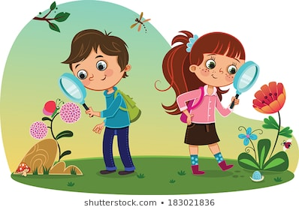  By looking closely at organisms for clues, we can often tell something about them. Perhaps where they live, type of climate they live in, what they might eat, how they move or even which group of animals or plants they belong to, what they are related to etc.  Look at the following strange animals and write down as much as you can about them, explaining what made you come to that conclusion. (Use the hints above.)  What about this one?  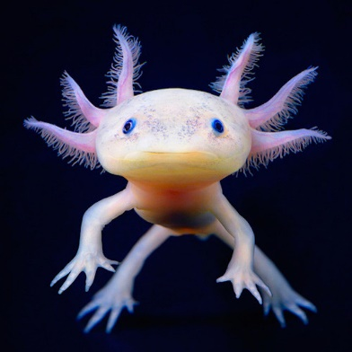  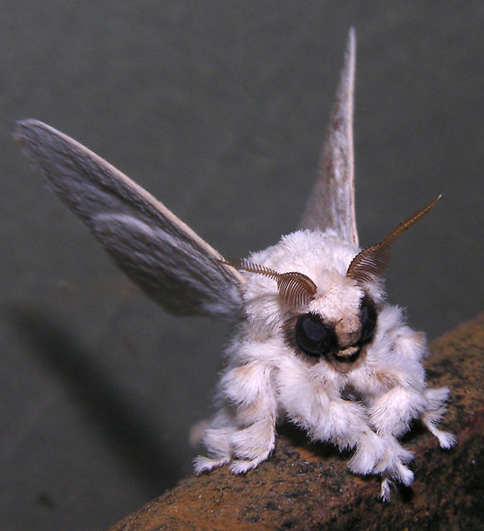  If you could name these animals, what would you call them? (Look out in Wednesday’s matrix to find out more about these animals)  DIGESTION: Attached below, you will find a crossword on digestion, created by Inaaya. Have a go and see what you can remember.

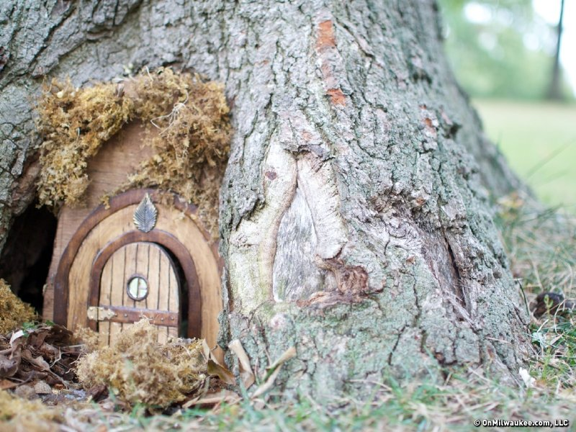
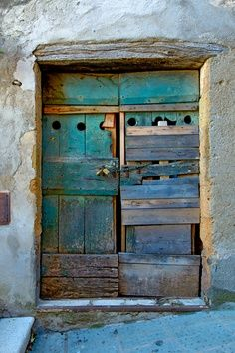
Digestive System Crossword by Inaaya (4TS)
2. |  |  |  |  |  | 3.
 |  |  |  |  |  | 4.
 | 5.
 |  |  |  |  |  | 6.
1.

Across
2. stores in the pancreas ______________
4. what your teeth do to food in your mouth _____________________
5. sends signals to the brain that you need to go to the toilet. __________________
6. Organ that tastes food _____________
Down
- ___________ is stored in the gall bladder.
3. After eating, your food goes there. _____________________

