Science Home Learning Challenges
We have recently had quite a bit of winter weather! Below are some Winter Weather Investigations that you could try, or research, at home.
Remember to ask an adult to help you before you investigate!

Winter Weather Investigations:

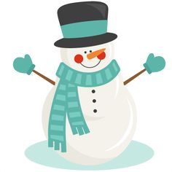
- Do you think a snowman will melt faster or slower when he is wearing a coat?
    - Can you explain your answer?
    - Can you prove it?

- Can you pick up ice with a piece of string?
(This is a little tricky – you may need an adult’s help and lots of perseverance!)
  - Fill a glass to the top with water.
  - Cut a piece of string around 20 centimetres long.
  - Place an ice cube in the water. It will float.
  - Lay the string across the ice cube and glass.
  - Cover ice cube and string with a layer of salt.
  - Leave for one minute.
  - Carefully pick up the ends of the string – what happens?
Can you find out why this happens?

- Does ice melt faster on a metal surface or a plastic surface? You could try this using a saucepan and a plastic chopping board!
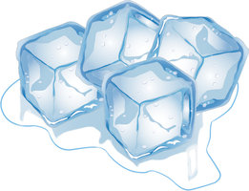
    - What did you notice?
    - Can you explain why this happened?

Miss Barr would love to see any Science Home Learning that is being done! You could take a photo of your investigation or write your explanation down and bring it to 2B. Green Cards will be given for the best explanations and photos!

