Year 6 Home Learning
Writing  You will recently receive a letter from your year 6 teachers. Your writing task today is to write back to us. Tell us how you are and what you’ve been up to. We are really looking forward to hearing from you.  Reading  Choose a dilemma from a story you have read.  Write a letter to the character, offering them advice on what they should do to solve the problem.  Spellings  Pick 5 words from the year 5/6 spelling list to learn. Can you think of a rhyme, saying or acronym to help you remember how to spell it?  Practise using those words in contexts. Write a sentence with them in and try to use a different English device in each sentence e.g. a semi-colon, brackets, dash, fronted adverbial etc…  Mindfulness  This is a good video clip to watch. It explains why and how we can lose control of our emotions. It would be great if you could spend a few minutes watching it.  https://www.youtube.com/watch?v=3bKuoH8CkFc | Maths  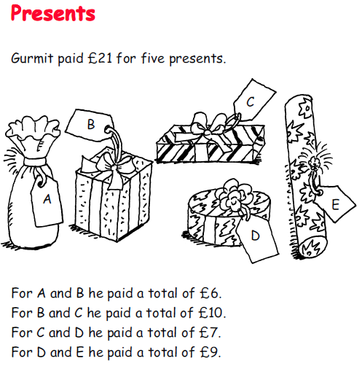  How much did Gurmit pay for each present?  Write your own problems using more challenging prices.
Science
Charles Darwin discovered that different kinds of birds eat different kinds of foods, because they are specialised. Their beaks have adapted to be the best shape for picking up the food they like best and is most available to them.
I would like you to carry out an experiment. First, you need to predict which ‘beak’ will be best for each ‘food’ type and test it simulating beak type with chopsticks, spoons, tweezers etc. This is a great way of showing how beak shape is important for a species as if it had a beak which was incompatible with its food source then it would eventually die out.
Attached is a sheet designed for a whole class experiment. Unfortunately, you will have to carry out this experiment on your own – or maybe with your brother and/or sister.
It looks incredibly exciting.

