Year 2 Home Learning
Week Commencing 13 July 2020- Monday
Please send your work to- year2@highworthcombined.co.uk
We always look forward to seeing your work. Please let us know if you need any help or have any questions.
English  Watch the video using the link below.  https://www.literacyshed.com/caterpillar-shoes.html  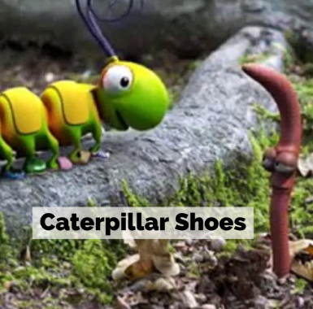  Activities-  - Did you hear all the rhyming words they used? Write down as many words as you can. Are they spelt with the same spelling patterns?  - Answer the following questions using full sentences using evidence to support your answer.  At the beginning of the story, what does the caterpillar like to do the most?  Why did the caterpillar want to give his shoes away?  Which shoes did the caterpillar give to the woodlouse?  Who did the caterpillar give his last show to?  What happened to caterpillar after he gave all his shoes away?  How did the caterpillar feel at the end of the story and how do you know?  Does this story remind you of any other stories you have read/watched?  - Can you list all the different creatures and their settings? | Maths  Complete the Maths Challenges Attached  You will need to think about all the skills you have gathered this year. This carefully and try to use ‘star words’ in any written explanations.
Reading  Read the story below about Firefighter Fiona and answer the questions.  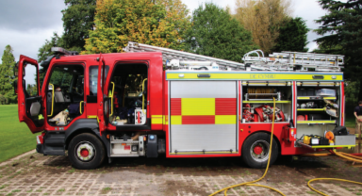 | Spelling  This week we are looking at root words that end in ‘y’. These words also have a consonant before the ‘y’. To make the words plural we need to add ‘es’ to the root word but we must also change the ‘y’ to an ‘i’.  The word baby becomes babies.  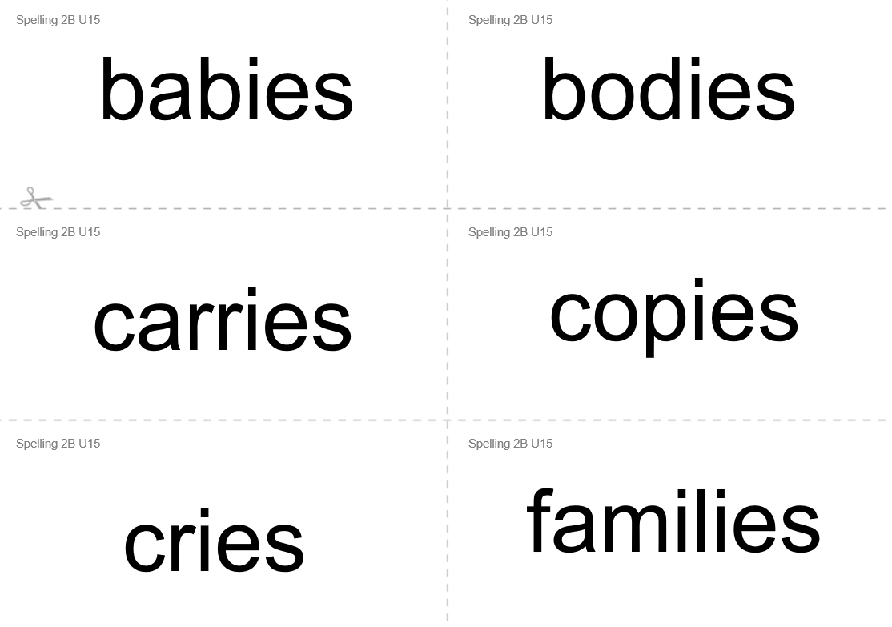  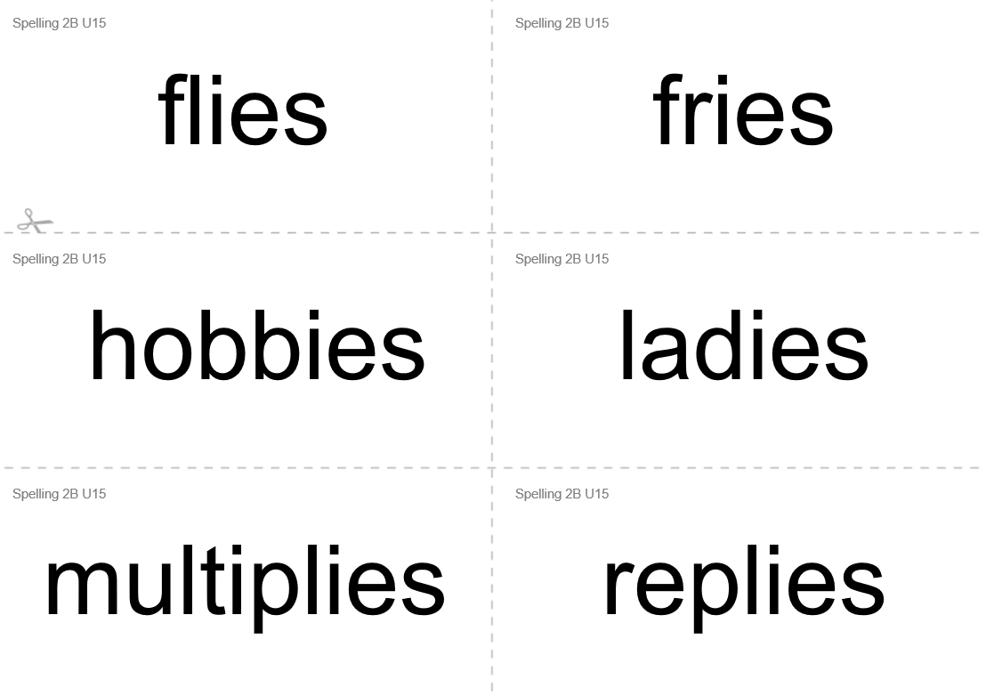  - Write 6 sentences using these words.  - Can you write a sentence using two or three words from the list?
Art  Back in March we made an origami boat together. I thought it would be fun to have a go at a different type of boat. Follow the instructions carefully and see if you can make the boat below. Pause the video as you go along.  https://www.youtube.com/watch?v=ocqaXHfjIog  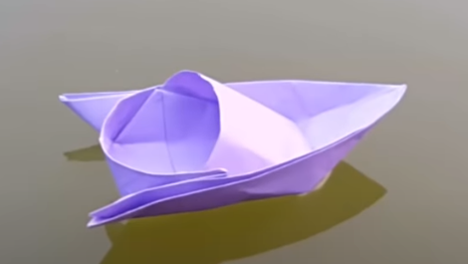 | Game  Have a go playing the Healthy Eating board game attached. What other board games do you like to play?  