Year 3 Home Learning – Friday 10th July 2020
X means that no internet access is needed. We look forward to seeing what activities you have enjoyed the most. Take a photograph of your work and send it to - year3@highworthcombined.co.uk
X  Quick mental arithmetic  1. 9 + 8 =  2. 23 - 6 =  3. 164 + 50 =  4. 345 - 100 =  5. 642 + 300 =  6. 525 - ? = 450  7. 9 + 15 + 6 =  8. 82 = 8 + ?  9. 7 less than 235  10. 9 more than 267  Recognising 3D Shapes (BBC Bitesize)  https://www.bbc.co.uk/bitesize/articles/zwscf82  Learn to identify 3D shapes. Watch the  short animation and then read about  different shapes and their properties.  Complete 3 activities  If you do not have access to the internet  complete the 3D activities on the next page. | Marvellous Music  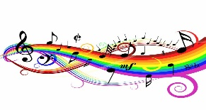  Learn what happens to our bodies  when we sing. Why does it make you  feel good?  https://www.bbc.co.uk/bitesize/articles/zfdwr2p  Watch two film clips about singing.  The first activity is fun and teaches  you how to warm up you voice before  you sing using vocal exercises.  Then learn a song and get tips on how  to give a great performance.  Think about the kind of music you  like to sing and why. | X  English  SPaG  Revision Quiz  On the next page you will find a list  questions to revise your knowledge  from your learning in Year 3.  It is a mixture of grammar, punctuation  and spelling and includes  homophones  conjunctions  direct speech  prefixes  suffixes  tense  using a or an  Have a go at answering all the  questions.
X  Remarkable Reading  The Sound Collector  a poem by Roger McGough  I hope you enjoy reading this well  known poem.  Read it aloud and then answer the  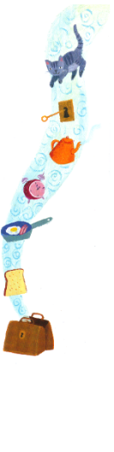  questions which follow. | X  Super Spelling  Y3 and 4 Common Exception words  Here is the next group of spelling. Write  a list using neat joined handwriting.  ordinary  particular  peculiar  perhaps  popular  position  Activity 1  Write each word twice. First write each  word in CAPITAL letters. Now write  each word in lowercase letters.  Example - ORDINARY ordinary  Activity 2  Choose 3 words. Write 2 different  sentences for each of these words to  show you understand their meaning.  Include adjectives and an adverb in  your sentences too. | X  Well Being  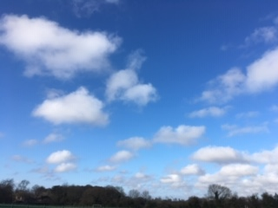  Clouds  Taking time out to be quiet and calm is  good for us. Spend some time  looking up at the sky during the day  and take notice of the clouds.  Can you spot different patterns?  Draw a picture of the clouds or imagine  that you can see pictures in the  different shapes.  What do the clouds you see look like?
Maths Activity - Identify 3D shapes and their properties. Edge
Face – a flat surface on a 3D shape Face
Edge – an edge is where two faces meet
Vertex – where two edges meet. Vertex
Vertices is the plural word for vertex.
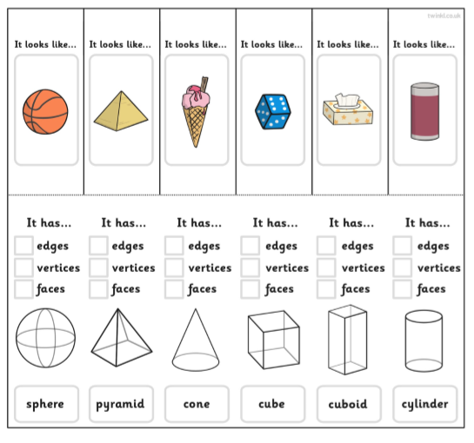
- Look at the 3D shapes above. Count the number of edges, vertices and faces for each shape.
- Use this information to copy and complete the table below.
3D Shape | Faces | Edges | Vertices
Sphere | one curved face | none | none

English Activity - Revision Quiz

Question | Write your answers here.
Choose which prefix goes at the beginning of this word.  marine | - auto b) sub c) re
Which conjunction would you use in this sentence?  I didn’t go to school _________ it was closed in the  Easter holidays. | - if b) while c) until
Write out the sentence using the correct punctuation.
Come quickly or we will be late for the party yelled Josh
Find three spelling mistakes in this sentence and correct them.

I didn’t notis that the car was parked oposit the libary.

Choose which word goes in front of the noun.  In the fruit bowl there was only ___ orange and a pear left.  Can you explain your choice? | a) a b) an
Identify an adjective and verbs in this sentence.  He crawled through the rough grass and peered over. | adjective _____________________________  verbs _________________________________
Match the correct suffix to go at the end of each word.  colour___ careful____ bright_____ | - ness b) ful c) ly
Write these verbs in the past tense.  - I bring  - I freeze  - I buy | a)  b)  c)
Use two adjectives to create an expanded noun phrase below.  The _____________, ________________, hero with  wings on his helmet. | _______________________, _____________________
Write the contractions for each of these words.  They are I will have not  Example - do not don’t | ____________ ____________ ____________

Reading - Poetry

Read the poem and then answer the questions.

The Sound Collector by Roger McGough

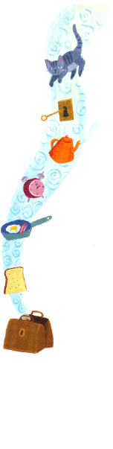
A stranger called this morning
Dressed all in black and grey
Put every sound into a bag
And carried them away.

The whistling of the kettle
The turning of the lock
The purring of the kitten
The ticking of the clock

The popping of the toaster
The crunching of the flakes
When you spread the marmalade
The scrapping noise it makes

The hissing of the frying pan
The ticking of the grill
The bubbling of the bathtub
As it starts to fill.

The drumming of the raindrops
On the window – pane
When you do the washing – up
The gurgle of the drain

The crying of the baby
The squeaking of the chair
The swishing of the curtain
The creaking of the stair

A stranger called this morning
He didn’t leave his name
Left us only silence
Life will never be the same.

