Year 5 Home Learning – Friday 22nd May 2020
Have a lovely Half Term break Year 5!
Please send us your work to: Year5@highworthcombined.co.uk we’d love to see it!
ENGLISH  We hope that you have been having fun with the activities to add to your virtual Time Capsule.  Look at the document – TIME CAPSULE PROJECT - (attached with Monday’s matrix) and let’s complete Friday’s now: ‘My community’. There are lots of ideas to get you started.  You might like to take a look at Saturday’s and Sunday’s activities and maybe even take some photos in preparation. However, we will return to these after the half-term holiday. | MATHS Number chains  Doubling chain:  Start with a number between 1 and 9.  Double the number.  If the answer is greater than 10, subtract 10. Then double again.  … Continue.  What do you notice?  Try different starting numbers.  Alternative chain:  Write down any 2-digit number.  Reverse the digits and find the difference between the two numbers.  Do the same with the answer … and again.  The chain stops when you reach a single-digit number.  Try other starting numbers, e.g. 25, 67.  What do you notice?
WONDERFUL WORDS
Look at the Year 5 & 6 Words List. You can find it as a link on our Coronavirus Closure, Home Learning Matrix, Year 5 tab: https://www.highworth.bucks.sch.uk/web/year_5/460996

Choose 4 or 5 words to practise at a time.
- Look up the definition in a dictionary to check the meaning of each word.
- Learn the correct spelling by using: Look, Say, Cover, Write, Check.
- Write a sentence which includes the word to show that you understand its meaning.
4. Challenge yourself to include a PLURAL word which requires a POSSESSIVE APOSTROPHE
in each of your sentences but BE CAREFUL because both of these are correct:
The teachers’ muscles were aching after their run. The children’s muscles were aching after their run.
WELLBEING
Many of us have times when we feel anxious or worried.
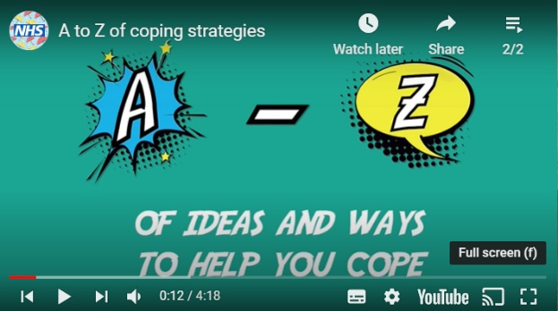
Watch this video for lots of great ideas of what you can do to help reduce your anxieties:
https://www.youtube.com/watch?v=5EXpkVw3fh0

Mrs Kern’s favourite idea is J for Jokes; to find
something that makes her laugh! Mrs Naidoo
likes the D to distract herself with cooking and
watching some telly! You might be pleased to
see the idea X for Xbox; it’s OK to have
downtime and fun!

Choose some of your favourite things that
help you to cope. They could be your own ideas or something from the video.

We’d love you to produce a poster to help others know what they can do when they feel anxious or worried. Remember to make it colourful and eye-catching!

Maybe you could put it on display somewhere at home?

