Year 6 Home Learning
English  If I had a superpower, it would be…  Turn yourself into a superhero! Have a go at drawing what you’d look like and then write us a paragraph to describe you. Things you may want to describe:  - Your job  - Your power  - Where you live  - Your home  - Your family  - Your desires  - Your fears  We can’t wait to see the Year 6 superhero class of 2020!  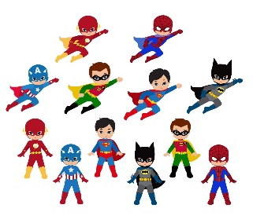 | Maths  Scavenger Hunt!  Ask someone (or set it yourself) to give you some lengths and weights in a grid, for example, 20cm or 300g. You then need to search around your house and try and find objects that are that weight/length. The person who is the closest to the lengths and weights that were set is the winner!  Additional challenge – actually measure the items you’ve chosen and calculate how close you were. Can you then convert your answer to mm, metres, km or kg etc…
Reading  Just read week!  Curl up with a good book in your favourite spot in the house and enjoy reading it You could read a story, a newspaper, a comic, a recipe book, an information text, an online article, a picture book…anything that you really love. My favourite spot is the corner of the sofa whilst making a cushion fortress around me and a cosy blanket! Perhaps you could email in where yours is or a photo of you reading in your favourite spot. | Topic  Continue to use the oak national website to revise our WW1 topic. Have you learnt anything in addition to what you already knew? We’d love to see or hear about this!  https://www.thenational.academy/online-classroom/year-6/
Spellings  Can you create a spelling word search for the spellings you’ve been practising? The easiest way is to write the words in first and then fill the grid with random letters. Remember you can write the words horizontally, vertically or diagonally. Email them into us to post up for others to solve! Remember to write the words people need to look for underneath your gird.  We’re attaching a grid you can print off or you could just draw your own.  Pick 5 words from the year 5/6 spelling list to learn. Can you think of a rhyme, saying or acronym to help you remember how to spell it?  Practise using those words in contexts. Write a sentence with them in and try to use a different English device in each sentence e.g. a semi-colon, brackets, dash, fronted adverbial etc… | Mindfulness  The year 6 teachers have been using this time to do something that they perhaps wouldn’t normally have as much time for.  Mrs Harris has been playing the piano, Mrs Smith has been busy knitting and Mrs Keating has been painting.  Over the next few days, take the time to do something that you enjoy. Perhaps it might be something you haven’t done in a while because of all the clubs you were doing or you’ve always fancied learning how to speak in Spanish. There are lots of youtube clips or websites that can help to get you started. We’d love to see your photos of these!

