Home Learning Ideas for all
Tuesday 19th May 2020

Mental Health Awareness Week
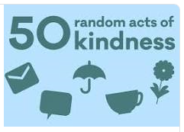
This week is Mental Health Awareness Week and the theme this week is kindness. The Mental Health Foundation have come up with 50 random acts of kindness. How many can you do? Can you take a photo of you doing a random act of kindness and send them in to us? We would love to see them! https://www.mentalhealth.org.uk/sites/default/files/50-random-acts-of-kindness.pdf

Oxford Owl eBooks
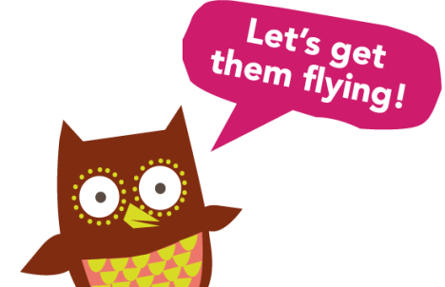
If you haven’t already registered, take a look at the Oxford Owl eBooks website. During this tricky time, children aren’t able to access reading books from school, but there is a huge range of great books on this website which are free for your children to read. To access them, you just need to register! https://www.oxfordowl.co.uk/for-home/find-a-book/library-page

Rock Painting
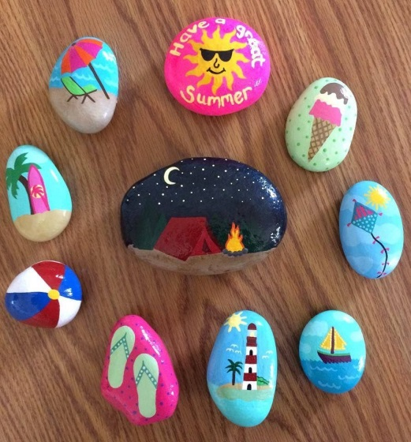
During your daily exercise, can you pick up some stones which you can take home to paint? You can then leave them out for other children to find when you next take a walk. I have spotted rainbow stones, stones with messages on and beautiful patterned stones on my recent walks!

