Summer 2 Week 4 Home Activities
Here are some suggested activities you could complete as a family. Have fun and keep well! Please do send us photos of what you have been doing at yearn@highworthcombined.co.uk

Literacy/Communication  Learning tongue twisters is a great way to develop speech and language. Have a go at learning these tongue twisters:  - She sells seashells by the seashore  - I scream, you scream, we all scream for ice cream  - I saw Susie sitting in a shoeshine shop  - I saw a kitten eating chicken in the kitchen  - If a dog chews shoes, whose shoes does he choose? | Physical  - Continue to keep practicing writing the letters in you name. Do you know the sound each letter makes?  - Have a go at PE with Joe Wicks each day.  https://www.youtube.com/watch?v=XwD23OPFnwE  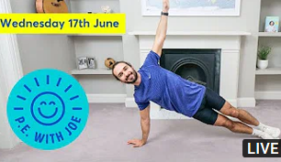 | Personal and Social  Mindfulness meditation is a great way to support wellbeing.  Support your child with having a go at learning about meditation.  https://www.youtube.com/watch?v=Bk_qU7l-fcU  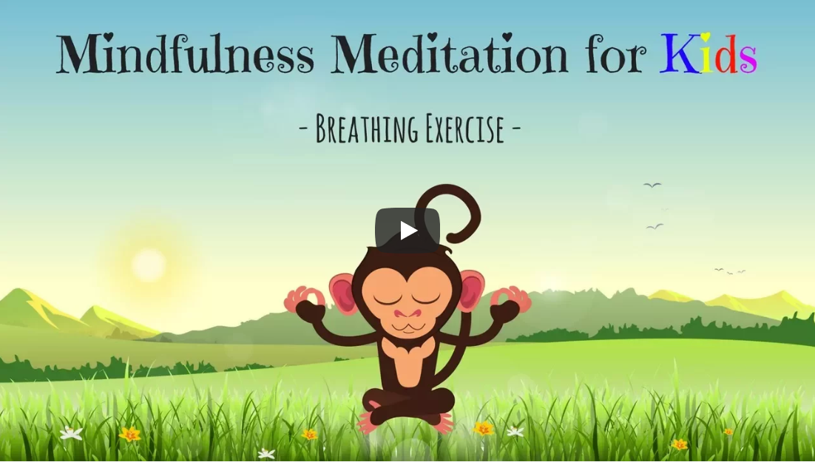
Mathematics  Baking is a great way to learn all about measurement.  Together measure out the ingredients and have a go at these easy to bake biscuits.  https://www.bbcgoodfood.com/recipes/easiest-ever-biscuits  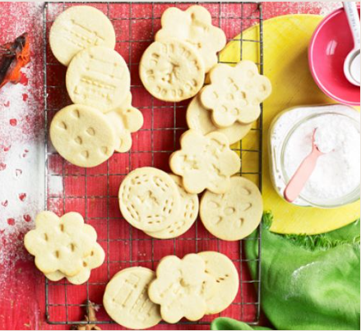 | Knowledge and Understanding of the World  Technology is all around us. Are you able to use technology to;  - Phone a family member using a mobile phone?  - Complete a simple programme on an i-Pad or a computer?  - Talk to an adult about different types of technology you might find in your house eg. TV remote controller, vacuum cleaner, washing machine and dishwasher etc.   | Expressive Art and Design  Whilst out for a walk take a look around you. Can you see lots of different flowers growing? What is your favourite flower? What colour are your favourite flowers?  Georgia O’Keeffe was a famous American artist who was known for her paintings of enlarged flowers.  Here is an example of a flower painted by Georgia O’Keeffe.  Have a go at making a drawing/painting of a flower similar to Georgia O’Keeffe.  

