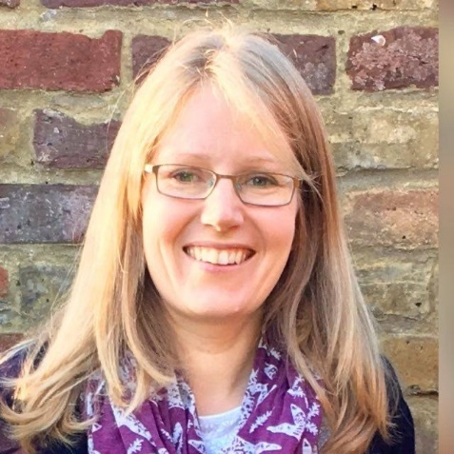
Hello, my name is Mrs Brain. I work as a keyworker in Reception for three days a week, usually on Monday, Tuesdays and Wednesdays. I am so looking forward to meeting you all in September and having lots of fun on our learning journey together. I love reading stories, cooking, baking and anything to do with animals, science and nature. I also like running and walking in the countryside where I live. I am a mum to 12-year-old identical twin girls who keep me very busy at home. My daughters love pets: at the moment they have two gerbils, a hamster and a Giant African Land Snail! I’ll see you all soon and you can tell me all about what you like to do.

