Home Learning Ideas for all
Thursday 26th March 2020

Audio book with David Walliams
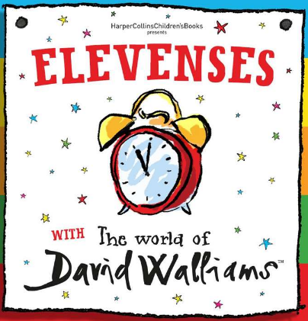
https://www.worldofdavidwalliams.com/elevenses/The Wind in the Willows the Musical
11am!! David Walliams has been reading some of his stories live at 11am each day this week. Get a drink and snack ready, get yourself comfortable and enjoy!
Why don’t you try reading aloud a story of your choice to your family afterwards? Can you get into character as well as Walliams can?!

Card Game - 24:
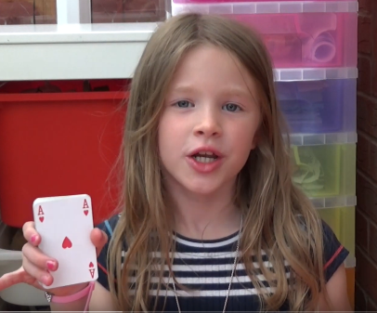
https://www.youtube.com/watch?v=HeO0q0cSvx0
Have you got a pack of playing cards lying around at home? If you do, have a look at this YouTube clip showing you how to play a game called 24… Enjoy!

And finally, go into Espresso (log on details on the Home Learning Ideas) https://www.discoveryeducation.co.uk/what-we-offer/discovery-education-espresso and select the correct Key Stage for you and complete the daily challenge.

