Home Learning Ideas for all
Friday 3rd April 2020

It’s time to unleash your inner wizard!
J.K. Rowling has created Harry Potter at home: https://www.wizardingworld.com/
Sign up for free and enjoy entering the world of Hogwarts… what house will the Sorting Hat place you into?

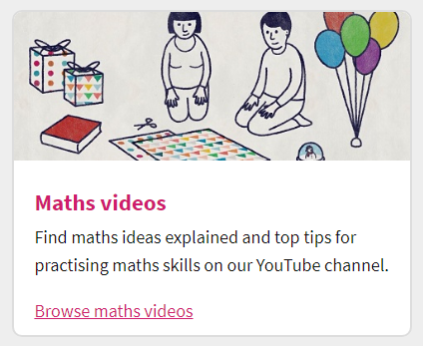
Free maths online activities, downloads and videos
Lots of you have been accessing the Oxford Owl website for the eBooks, spelling and phonics. In addition, it has a wealth of free maths resources for all ages – definitely worth a look if you have not yet done so.
https://home.oxfordowl.co.uk/kids-activities/fun-maths-games-and-activities/

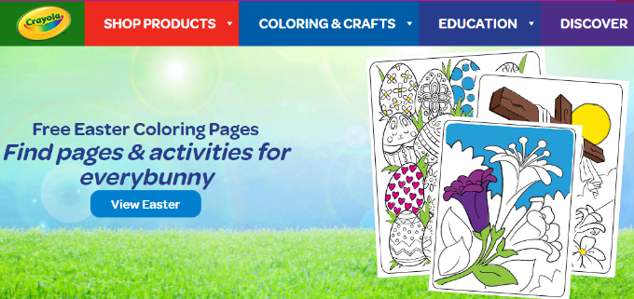
And finally, for those of you who have a printer, Crayola is offering free printable colouring pages. Go to https://www.crayola.com/featured/free-coloring-pages/
Colouring is therapeutic for all ages!

