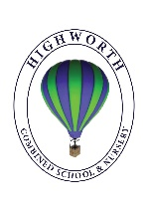
Home Learning Ideas for all
Thursday 14th May 2020
Blue Peter music challenge!
It’s Mwaka Mudenda’s first day as a Blue Peter presenter today. On Radio 2 thing morning, she set a challenge for you to try to earn a Blue Peter music badge by recording yourself singing, humming or playing an instrument to the Blue Peter theme tune. Application forms for the badge can be downloaded here:
https://www.bbc.co.uk/cbbc/joinin/bp-music-badge Blue Peter is on CBBC1 at 5.30pm

Wind in the Willows the Musical
World Guinness Record attempt – be part of it!
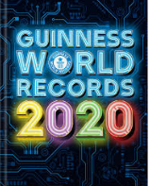
Register today to be part of Rob Biddulph’s largest ever online art lesson! Next Thursday at 4pm – 4.30pm join tens of thousands of other keen participants who will be making history…from home! Click here to register – we will set this as the home learning challenge for next Thursday too, but Rob would love you to register your interest today! http://www.robbiddulph.com/draw-with-rob

Make up your own board game
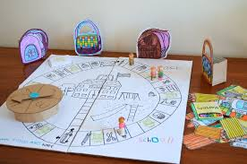
Why don’t you make up your own board game to play with your family? You could work together as a family to create your new board game, or you could design and make it on your own… let your imagination run wild and happy designing, building and playing! We would love to see any example of games you’ve created!

