Week 5 Nursery Home Activities – w/c 29/06/2020

Here are some suggested activities you could complete as a family. They are linked to our Early Years Foundation Stage Curriculum and current learning. Have fun and keep well!
Literacy/Communication  Fill two bags with toys characters. Cover your eyes and choose a toy from each bag. Choose which toy will be the ‘goodie’ and which will be a ‘baddie’. Can you create story for them? Can you share your story with your family?  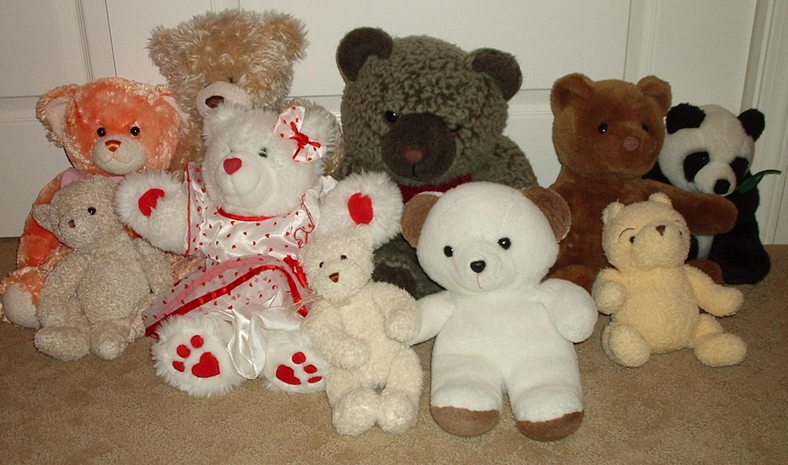 | Mathematical Development  Ask a grown up to write the numbers 0 to 10 on pieces of paper and hide them around a room or garden. Now can you go on a number hunt for all the numbers! Each one you find can you tell the grown up what number you have found.   | Knowledge and Understanding of the World  Can you go on a Scavenger Hunt indoors/outdoors and can you use your five senses to find…  Something that is…smooth, rough, soft, that has a smell, something that you can eat?  
Physical  Can you choose three dance moves and put them together to create a new dance to music. Can you now preform to them to your family?   | Personal and Social  Can you create a warm soapy bath for your favourite toys to be washed? How will they dry? Can you squeeze them thoroughly before leaving them to dry?   | Creative  With an adult look through the recycle bin for clean items. What can you make? A robot, your house, a dinosaur?  

