Year 5 Home Learning – Monday 22nd June 2020
We’d love to see your work! Please send it to: Year5@highworthcombined.co.uk
ENGLISH Writing  Wizards  Today we are working on alliteration.  Alliteration is when the words in a phrase start with the same sound.  E.g. The wise wizard was walking wilfully in the woods.  Read the worksheet on Alliteration and complete the alliteration game. Have fun! |  | MATHS  Measurement  This week we will be working on measurement.  Over the next two days we will be looking at the mass (grams, kilograms, tonnes) and capacity (millilitres, centilitres and litres).  Look at the knowledge organiser and learn the key words.  Take careful note on how to convert between the units – it may seem tricky but it is only multiplying and dividing by 10,100 and 1,000.  Have a go at the worksheets for practise - refer to your knowledge organiser for help.
WONDERFUL WORDS
Look at the Year 5 & 6 Words List. You can find it as a link on our Coronavirus Closure, Home Learning Matrix, Year 5 tab: https://www.highworth.bucks.sch.uk/web/year_5/460996
Choose 4 or 5 words to practise at a time.
- Look up the definition in a dictionary to check the meaning of each word.
- Learn the correct spelling by using: Look, Say, Cover, Write, Check.
- Write a sentence which includes the word to show that you understand its meaning.
4. Challenge yourself to use expanded noun phrases in each of your sentences.
Scroll down for the Help Sheet and Practise Activity to get you started.
RE  Buddhism  Complete the next lesson on Buddhism using the link below to find out what life is like for Buddhist monk and nuns inside a Buddhist monastery:  https://classroom.thenational.academy/lessons/what-is-life-like-inside-a-buddhist-monastery  You will need paper, pen and your brain! | Reading  We are certain that most of you have read or will read a book by Michael Morpurgo.  Read the text about Michael Morpurgo and identify all the words that you don’t understand.  Try to find the meanings of these words, either by looking at the sentences around the word or using a dictionary.  Next, answer the questions that follow and check your answers using the answer sheet. |  | Science  Volcanoes  This week we are going to learn about volcanoes and what happens inside them to make them erupt.  Watch the video:  https://www.youtube.com/watch?v=_GwOEtZ7pos&feature=youtu.be&utm_source=twigeducation.com&utm_medium=email&utm_content=june-18-2020-summer-school&utm_campaign=tsr-summerschool  Can you write a summary about what you have just learnt – take note of all the key words that you heard.
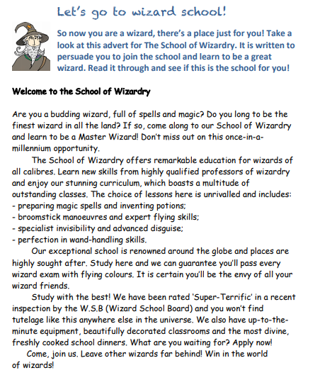

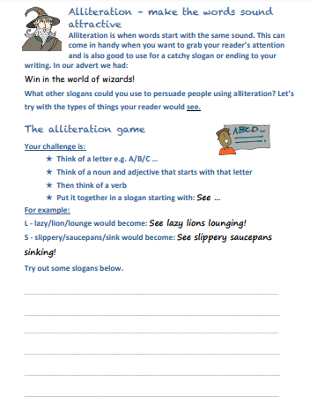

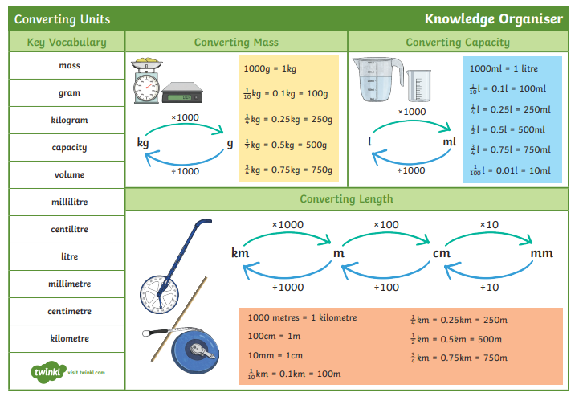
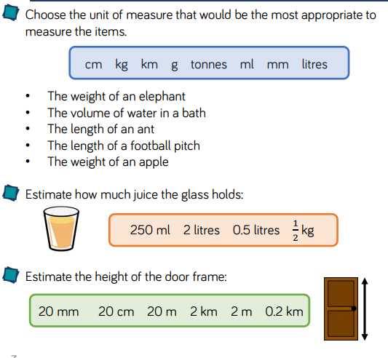
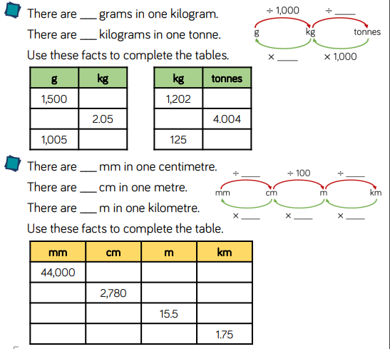
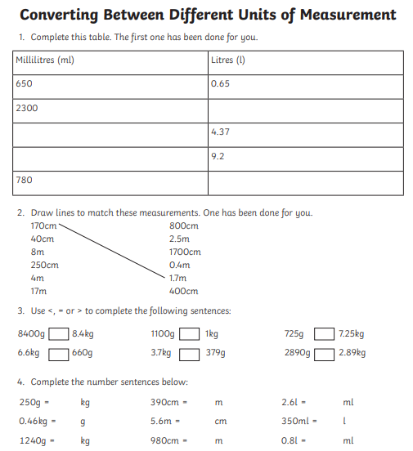

ANSWERS
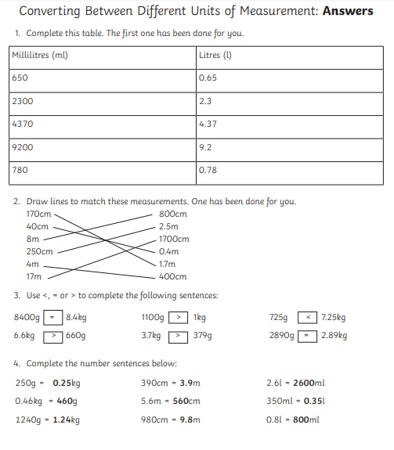

Help Sheet
Expanded Noun Phrases

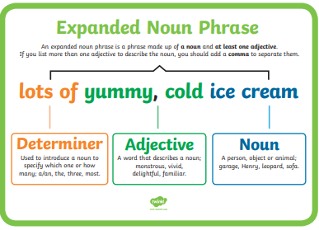
Scroll down for the practise activity.
